2023/2024

Patrick Williams

8123

Private Candidate

ocr erl interpreter

computer science nea

analysis

# project identification

In the OCR Computer Science GCSE, all programming code will be presented using the OCR Exam Reference Language (ERL). This is their equivalent to a high-level programming language and is designed to have simple and pseudo-code like syntax to be widely understandable.

Especially in paper 2, it is vital that the students understand the language as they will need to be able to understand programs written in it, as well as completing sections of it in larger template programs, as well as being given the option to write in it for the longer “Write” questions.

Unfortunately, students become familiar and comfortable with a language through usage, and the large majority of students lean towards using other high-level languages – primarily python – throughout their paper due to a lack of usage prior to the exam. Therefore, to help benefit GCSE students, I intend to create some form of translator, which would allow students to write ERL code, and for the program to then translate and execute that code for them in order to allow for practice.

## issues with high-level languages

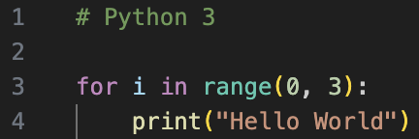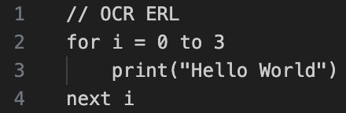OCR has attempted to design the papers in a way that ERL can be used interchangeably with other languages, however there are differences in the syntax which may lead to confusion and a potential loss of marks in the exam.

🡺 Inclusivity and Exclusivity

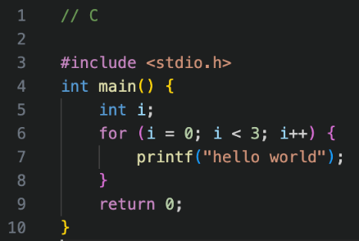When comparing the two code snippets on the left, they look very similar, but the ERL will iterate once more than Python – the more familiar language – as its counter-controlled loops are inclusive rather than the typical exclusive.

This may seam unique to Pythons range() function, but in more standardly defined loops, such as in C, it is the equivalent of ERL using <= rather than <, which is expected, therefore potentially causing confusion during the exam .

🡺 Differing feature-sets

This, again, vastly changes depending on the language. For example, a regular user of python may be confused by the premise of a procedure compared to a function, as well as being told to use a switch statement potentially not being in their vocabulary.

The worst instance of this, however, is with in-built methods. Only certain standard methods are allowed, such as length and string manipulation methods. However, if a student who is used to python decides to use min(), max() or .sort() in their written example, then they will be awarded no marks for that section of the program as they have shown no coding ability of knowledge. Being familiar with ERL, even if not using it for “Write” questions, will help educate students on which methods they can and cannot use.

🡺 Small syntax changes

These changes most likely would not lose the student marks in “Write” questions, but if the students are unfamiliar with them may cause confusion when reading ERL algorithms.

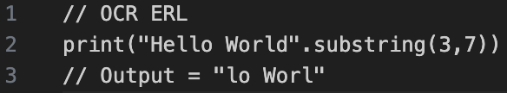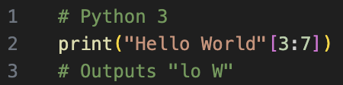Firstly, the typical parameters for the start and end position of a substring has been changed to the start and length in ERL, which is important to recognise.

Some other small syntax changes include:

* The use of closing keywords such as endif and endwhile (not frequently used in modern languages)
* The use of MOD and DIV rather than symbol equivalents which they may be used to
* The use of ^ as an exponent, compared to ** which is more frequently used.

🡺 Learning resources

Even though it could be argued that a high-level language could be used in the exam, the vast majority of textbooks use ERL in all their examples due to the fact that there are differences in all high-level languages, and it exists as a means to link together the GCSE students. Therefore, if a student is primarily learning how to code whilst using ERL, it makes sense to practice with it too.

## the solution

It is clear that the ERL is important to understand, so therefore a translator would help students complete practice questions – where they are written in ERL – and actually have a result to check and ensure that their solution works. Furthermore, it would help to transfer skills between different languages, as a semi-experienced programmer could test programs in ERL to see the transferability of their skillset into the exam. Finally, for complete beginners, it provides a way to run this very English-like language in order to introduce them properly to coding for the first time without the complexities of other languages.

It will also benefit teachers, as it will become much easier to explain the ERL to students and allow them to practice in lessons as it aligns with their teaching resources and is a much more logical approach to the exam. It would also be very useful for demonstration, as a key element of programming is the thought process behind it, so showing the class how to construct more complex algorithms – which at GCSE are generally sorting algorithms – alongside an actual result which also allows for easy debugging.

# stakeholders

There are two primary groups who would be utilising the solution: students and teachers, and there are generic descriptions for both of these groups.

|  |  |
| --- | --- |
| Students | Teachers |
| First time programmers with minimal experience | Knowledge of programming and ERL |
| Using restricted or low-performance devices | No restriction on software downloads |
| Difficulty installing complex software | No issues with installing software |
| Require an intuitive solution with help available | Still require basic error information |
| Would be helpful to include learning features | Solution must be presentable and teachable |

I will specify further with my stakeholders as to the exact details, but overall, a simpler solution seems to be ideal, as a translator which includes too many settings or features seems overly complex for new beginner programmers who are just trying to write very basic programs.

In terms of stakeholders, I have a current GCSE student who is the target user, a past GCSE student who has experience using the ERL and revising with it, as well as a computer science teacher in order to see how a possible solution could be implemented into a classroom.

## beginner programmer

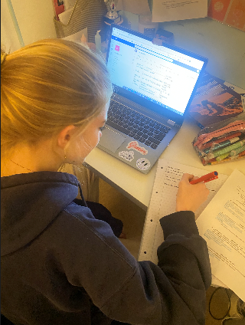Abigail Williams is a student in year 10 who has been studying computer science in some form for 3 years but has only begun learning the OCR GCSE specific content this year. I asked her questions about her computing background.

🡺 What are your past experiences with programming?

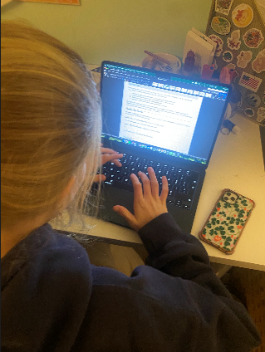“My previous experiences with programming have been rather bad because I struggle to understand the computing language format and how it all goes together. On top of this, it takes me a long time to type it out in the language, and I would prefer it was simpler and more like English.”

🡺 What’s your experience with the Exam Reference Language?

“What’s the exam reference language? I have used python before in the past, but I have never heard of this one until like 5 seconds ago.”

**(After an explanation)** “Okay, that seems important to know if it’s going to be used in the papers, so I should probably make sure I learn about it a little bit”.

🡺 What are your plans to revise coding?

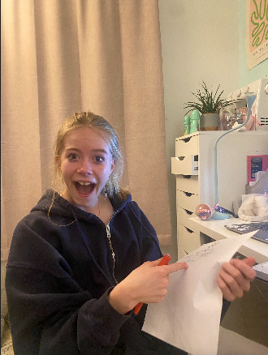“I’m going to make a revision booklet and write notes in it about the rules of the language that I’m going to use so I can try and remember. I know practicing is meant to be good, but I don’t know how to, and it sounds very difficult so I’m not sure if I will.”

**🡺 Conclusions 🡸**

The key element of this is her very small amount of experience with programming. Although this may reduce how useful her feedback is during an iterative development process, it is important to consider that she is the main user of the program, so later on her ideas for usability should be very constructive.

## past gcse student

Tanish Arjaria is a year 12 student who did OCR GCSE Computer Science last year and achieved a grade 9, who is now continuing to take Computing for A-Level. He is therefore a very high-achieving student, ideal for providing feedback about the process behind building the translator, however he is not a realistic end user as he is past the point of learning about ERL, and no longer has a need to use or practice it, but his experience will be useful.

🡺 Did you use ERL or a high-level language in the GCSE?

“I chose to write in python in the exam papers. Although I know a decent bit about ERL, I am not as confident in using it as I am with python, so I felt as if it was a less risky choice. However, for the questions where code had already been written in ERL, such as the fill in the gap ones, I did write in ERL.”

🡺 How did you practice using ERL?

“I looked at online ERL cheat sheets before exams and saw questions where it was used in past papers. Apart from that, I have never practiced using ERL at home, because I didn’t know where to find questions like we did in class.”

🡺 Did you find the experience of revising ERL easy or difficult?

“I didn’t spend much time deliberately practicing ERL, so it’s hard to describe it solely as easy or hard. It’s more of a thing where a random ERL question comes up whilst revising different topics, but I didn’t have a single set way to revise it – so I guess in that aspect it was kind of difficult as there’s not much option available.”

🡺 Would a translator for the ERL have aided revision?

“I be so for real; it would have genuinely helped as I didn’t spend any deliberate time on ERL at all. Even though I am confident in programming generally, so it wouldn’t have helped in terms of improving those skills but making me more familiar with the syntax and stuff would have just made the exam a bit easier”.

**🡺 Conclusions 🡸**

Tanish seems very comfortable with programming, so will make good assistance. He does reinforce that this solution would be very useful for all students, even himself as a comfortable programmer, which helps to bring focus onto the translator. It is meant to be designed as an educational tool over a powerful machine, so making it friendly in design and clear to use will be very important.

## computer science teacher

D

# translator research

This section will comprise of three different sections: researching current solutions for running ERL code, other translator designs, and some initial research into translator design. Afterwards I will then go into more depth about features – what my stakeholders want included and researching what I feel is important.

## pre-existing solutions for erl

### A white sheet of paper with black text Description automatically generatedTrace Tables

Students should already be familiar with trace tables, as there are questions in the exam papers, for example this one from the sample paper, of students being required to use them to “run” ERL code. However, when used in this different context it operates slightly differently.

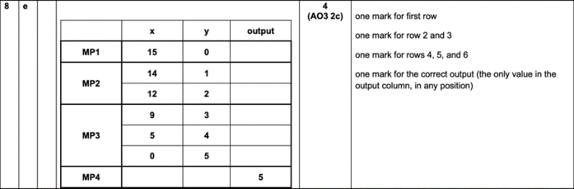🡺 Advantages:  
+ Already understood by the student so is familiar  
+ Helps to check the program’s logic is correct  
+ Used as a debugging tool to track the values and easily identify errors  
+ No software required, very accessible to all students

🡺 Disadvantages:  
- No syntax checking, so invalid inputs are treated as correct  
- The end result is based upon the individuals understanding of ERL, so if they misuse a feature it will be executed based upon that flawed understanding, with no proper feedback on whether it is acceptable  
- Extremely slow progress to create, especially with larger programs and with nested loops, so is too inefficient to use regularly, especially when repeated run-throughs are required due to errors.

🡺 Conclusions:  
Trace tables are too unreliable and slow to ever be used as a translator equivalent, however the positive aspects of simplicity are important to consider. Furthermore, the accessibility is important, and this highlights that as we need a translator that will be available to a wide range of students.

Finally, this could be considered as a potential implementation to the translator, to provide some form of debugging tool which the students are used to, without some of the complexities of more capable debuggers. If it is within the overall scope of the program, this could therefore be considered.

### manual translation to other languages

This is not a very technically proper approach but was a method I used in class to avoid creating a time-consuming trace table to run through my program. As I was comfortable with Python, after creating my ERL code, I would go line by line and enter the Python equivalent into a file, then run it to create my result, which would then allow me to check if the logic behind my program was correct.

🡺 Advantages:  
+ The computer produces a result at the end, therefore checking the logic behind the program  
+ Develops skills in ERL and a high-level language, providing the student with some real life skills  
+ Re-reading their own ERL is a form of checking for errors whilst translating to the other language

🡺 Disadvantages:  
- The ERL stage becomes very redundant, with not benefit to even including it when a high-level language can be used in the exam anyway, with no short-term benefit to writing the program out twice  
- Similarly to the trace tables, the student is the translator, so if their knowledge of the syntax or logic behind ERL is incorrect, then their translated program will not be accurate either, which defeats the purpose  
- Too time consuming, essentially re-writing the program is painful

🡺 Conclusions:  
Another poor current solution to translating ERL and should never really be used in a classroom. This highlights that the solution must be quick to use, as otherwise a student would never choose to use it. The link to real high-level languages could be considered, with a potential feature translating the ERL code to Python to link the two, however that may be too far out of the scope as is not the core feature.

### in conclusion

Overall, a translator for ERL seems very useful as there are currently no quick and easy solutions to the problem. In terms of focusing the project, it seems better to lean towards an Interpreter: the program gets executed on a click of a button rather than creating separate executable files. Whether the program approaches this line by line or the entirely at once is unimportant currently, as it will be abstracted to the user, but ensuring the program is easy and logical to use is critical.

## translators

Interpreters are usually designed around experienced programmers, which is not ideal for our solution, so despite these interpreters being very well made, I will be analysing them based on their use for new programmers – such as GCSE students.

### A computer screen shot of a code Description automatically generatednode.js in the terminal

This is a command line interpreter for JavaScript which can be called by “node” to launch the program.

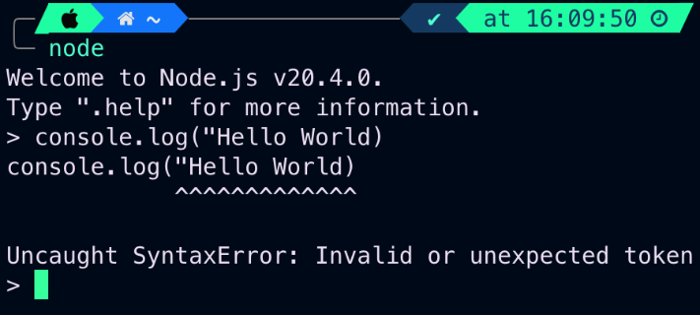🡺 Advantages:  
+ Good error handling, with detailed messages pointing to the position of the error in the line – useful for beginners  
+ Multiple use modes including the shell (useful for a few lines), an editor (useful for questions), and a feature to run local files (useful for any larger projects) – making it good in a classroom.  
+ Has a basic .help feature which it tells the user about, providing access to the useful features which is needed.

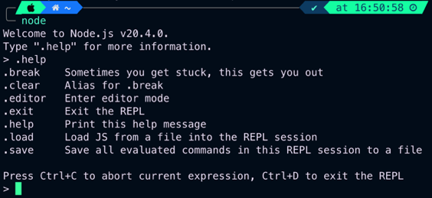🡺 Disadvantages:  
- No graphical user interface, making it difficult to use for new programmers who need something intuitive.  
- The terminal is often blocked on school devices  
- Complicated installation may not be feasible for students at home, and would require administrator access at school  
- Must memorise commands for fluent usage, tedious for beginners.

🡺 Conclusions:

Overall, I feel there are 3 main takeaways from node.

* Ensure that proper error handling is implemented, with good detail and pointing to the position.
* Make sure the interface is intuitive and is targeted towards beginner students.
* Prioritise accessibility, avoiding complex installs in the final product.

### Python idle

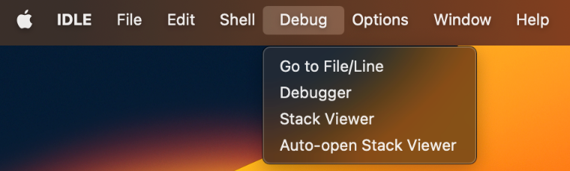My points will build upon the previous, expanding upon the features it includes.

🡺 Advantages:  
+ A vastly improved user experience, using a ribbon to implement the functionality, which is much more intuitive than commands for beginners.  
+ A much nice user interface, with syntax highlighting and proper indentation (which will also be important for ERL), which is much more pleasant than the command-line implementation.  
+ A greater array of features with “a debugger, with persistent breakpoints, stepping, and viewing of global and local namespaces” – which could be of use to a student

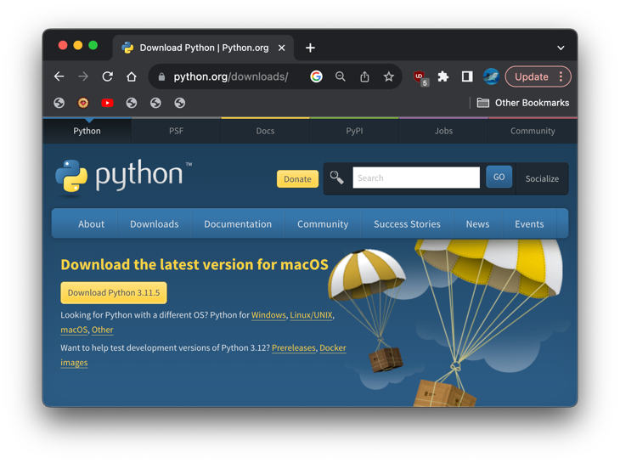🡺 Disadvantages:  
- As useful as some of these features are, they will never really be used by absolute beginners due to their complexity, so may be redundant.  
- An installation is still required, which may reduce accessibility  
- The official documentation is dense and hard to understand. There are still countless python tutorials on the internet – but in terms of an official equivalent for ERL – an easier solution would be required.  
- Having to save files in the editor before running can be annoying and complicated.

🡺 Conclusions:  
Visually Python IDLE should be a strong influence, as its focus on the code is important. In terms of improvement, just further decreasing the complexity would be good, such as by removing installation and adding more buttons to the project to make it even simpler.

### Replit

Replit is an online IDE, allowing people to write code on their website, which is then run on their cloud servers and the results are returned to the client.

🡺 Advantages:  
+ Very accessible solution, and a website seems like the best solution so that it is available to all students with an internet connection without any install.  
+ The cloud servers ensure that all low-performance devices can still run code, therefore making it available to all students and very suitable for school devices  
+ When talking to a student who has used it before, Dylan Matthews, he said the main positive was the community aspect, with lots of users sharing their code and problems creating a learning environment.



🡺 Disadvantages:  
- Although there are some good aspects of the interface, such as the run button and separate editor and shell windows, overall, it feels very cluttered and overwhelming for a beginner.  
- Having account systems and being required to sign in is also overcomplicated, as ERL questions would only require short algorithms to be written, not requiring saving, and creating an account just slows the whole process.

🡺 Conclusions:  
As great as running the code on cloud servers would be for my project, this is beyond the scope of the project, and would be largely redundant due to the simple ERL code. However, a website seems like a promising idea, and I would therefore like to take this forward as it seems perfect for students at school.

## Translator design

This is split into two sections: ERL specific and generally for translators

### For Exam reference language

It is important to recognise the entire set of instructions that need to be implemented, which are available on the exam specification at the following list:   
<https://www.ocr.org.uk/Images/558027-specification-gcse-computer-science-j277.pdf#page=27>

# Success critera

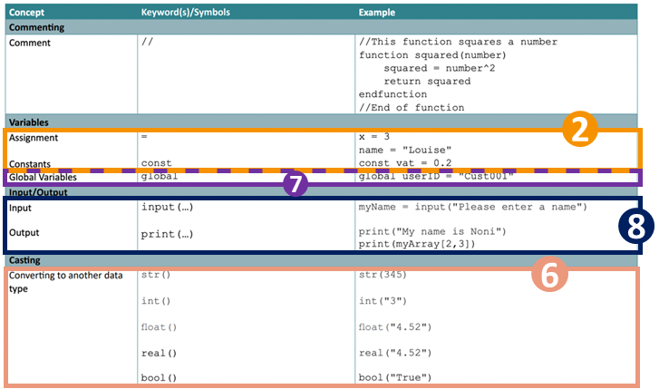The main and obvious section of my criteria is the exam-board documentation of ERL.

This has been divided into eleven modules which, when designing, I will go through, and iteratively design and develop and evaluate.

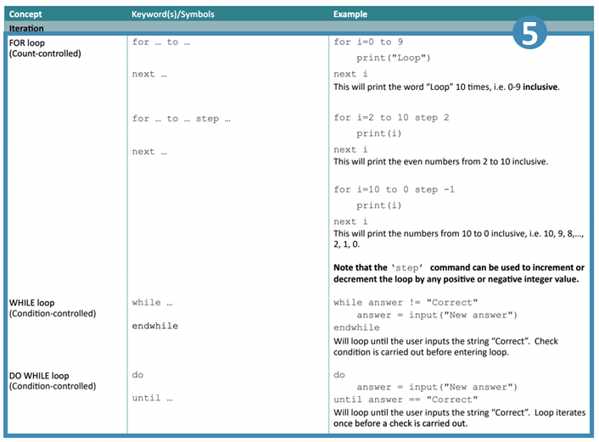The contents of each module is very straightforward, and more detail is to follow, but highlighting the entire specification makes it clear that the entire codebase is going to be implemented.

These have been arranged in order of importance, and If less than 9 are completed, then the project will be deemed a failure as otherwise a lot of the key features will be excluded.

10 and 11 are also aims, but are more niche and less frequently used aspects of the ERL, so therefore could be excluded but it ideally should be involved.

Overall, the order is:

1. Arithmetic
2. Variables
3. Logic and Statements
4. 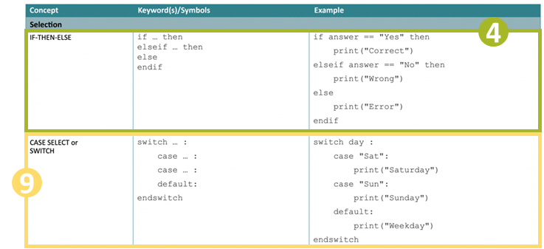If statements
5. Loops
6. Strings and casting

* **Mid-way Evaluation**

1. Functions and procedures
2. Input and Output
3. Switch and Arrays
4. String methods
5. File handling

* **Interpreter Evaluation**

1. User interface

* **Final Evaluation**

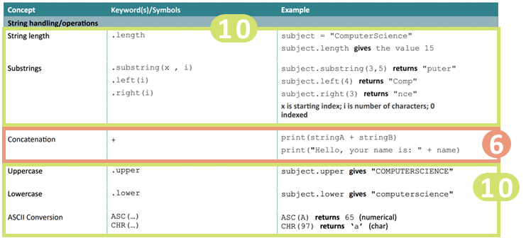The final stage implementing the Interpreter into a website, which should be relatively straightforward as it is written in javascript but is important to provide accesibility for the user and to allow a proper means of use.

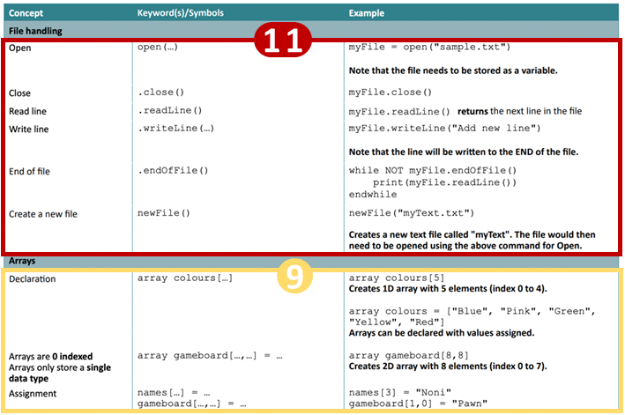

## 1: Arithmetic

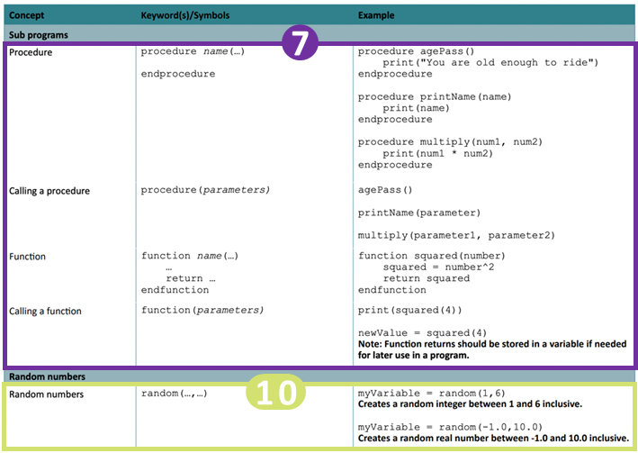Design **and** developmenT

My design and development sections are going to be integrated into one, as instead of planning the entire project, and then coding the entire project I feel like the better approach is to tackle it one module at a time, as this allows a lot of room for my program to evolve. Therefore, I will design each module before starting development, then develop it, making changes from the original plan, and testing each newly added feature for all of the use cases.

Doing this allows any changes I make in development to not affect the later stages of the program, because a lot of code in an interpreter builds on previous code, so any changes could leave the rest of my plan redundant which would be a large time loss.

## References

This is a list of some of the sources I have used for the project. This was only really relevant in the BODMAS stage as afterwards I used completely my own concepts; however I never directly copied any code: only seeing how the overall structure of the Interpreter had to be built.

🡺 [https://youtu.be/SToUyjAsaFk](https://youtu.be/SToUyjAsaFk?list=LL)  
🡺 [https://youtu.be/JO_0e9mPofY](https://youtu.be/JO_0e9mPofY?list=LL)  
🡺 <https://craftinginterpreters.com/a-map-of-the-territory.html>

# design: An overview of interpreting

This first section is going to be an overall demonstration of how my interpreter is going to function. We are going to take a relatively basic arithmetic expression, in plaintext, and go through the logical steps the interpreter will take to produce a result. This includes the three main stages: lexical analysis, parsing and then execution. I will later go into detail about the plans to code each stage, but this is a general abstracted explanation of the process which removes all the complicated details.

## Lexical Analysis

The interpreter will take a plaintext input, for example being the one below, which we will be using throughout this demonstration to eventually produce a result.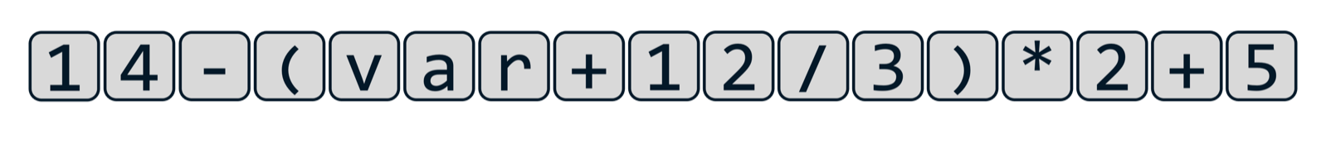Currently, to the computer, this string of characters holds absolutely no meaning or value, so in lexical analysis, the meaningless string of characters is converted into a list of tokens. This is done by a program called a lexer.

On a simplified level, the lexer takes a line of the input text, and goes character by character, looking at the type of character or arrangement of characters, and converts it into a list of objects, which are called tokens. Some characters are very easy to convert into tokens, such as parenthesis, however, when tokens which are longer than a character long become involves, it requires much more difficult code to distinguish multi-digit integers, strings, floats and variable names.

The lexer must also be trained on what to ignore, including white-space characters and comments, as what is produced at the end of the lexing process must be a list of meaningful tokens which can be given to the parser so the next stage can start.

In terms of the tokens that are produced themselves, they are all objects, as I am using an object-oriented approach to this project. Every single token has a token type, and every single token type has its own class, with different properties. Throughout the process, we will define and create different types of tokens, but for now we have four different groups of tokens.

🡺 Literal tokens hold values, with different types being integers, floats, Booleans etc. They will have a property called value which, obviously, holds their value.

🡺 Identifiers, at this stage, are variables, and will later include function and procedure names. For now, they would have a property which points to the location of their value in the program (to be expanded on later)

🡺 Binary operators are the arithmetic operations, including adding, subtraction, multiplication and so on.

🡺 Finally, there are other kinds of characters, such as parenthesis and dots, which may be included.

At this point, the objects still hold no logic or meaning behind them but is merely the plaintext described in a way that a computer could begin to understand it: the equivalent of us reading a sentence, but not yet understanding the grammar and meaning behind it.



Using our example, at the end of the lexical analysis stage, we have been left with this array of tokens which is equivalent to the plaintext, ready to be passed onto the next stage of the process.

## The basic concept of parsing

Parsing is the most complex stage out of the three and is where the tokens from the lexer are given a meaning, a grammar, that means something to the computer. This is where our simple list of objects is built into an abstract syntax tree, which is a type of data structure. Where each of our objects is linked in some way to another object, as its children. The job of the parser is to correctly link all these objects together in the correct structure based off the rules that we give it.

These set of rules become very complex, but in our example, the computer needs to arrange the objects based on the mathematical principle, order of operations. This has two key parts:

🡺 Precedence: the order itself. This is how certain features have priority, with items in parenthesis being calculated first, then any exponents, then multiplication and division, then addition and subtraction, according to the BODMAS structure of mathematics that we use.

🡺 Associativity: this is the order in which operations with the same precedence are executed. For example, a chain of subtractions will result in a different value based off whether they are calculated from left to right or from right to left. In BODMAS, this is from left-to-right for arithmetic expressions.

Based on these rules, the tree is created, with the calculations that need to be performed first at the bottom of the tree, and this is the overall premise of parsing before the result is produced.

Although this may seem simple with our BODMAS example, the premises of precedence and associativity are still present for all other aspects of the language. When keywords and different data structures and functions and all the specific features of the language become involved, it makes this parsing step extremely complex to create.

### What are the set of rules?

In my brief description, I described how a set of rules determined how the abstract syntax tree would be created. This sounds extremely vague, but it needs to be extremely precise in the actual code. This is where a special kind of notation is used, called Backus-Naur form - or BNF for short - is a context-free grammar used to describe the how the logic behind a grammar is defined.

#### A basic example of bnf

For this we will be defining what an integer is using BNF. There are a few key aspects of BNF. The definitions by themselves may not make much sense but will be clear with context afterwards.

🡺 name = a terminal (aka lexemes), this means it is in its lowest state, and cannot be expanded upon, for example the digit 1 is a terminal as it is clearly in its defined form

🡺 <name> = a non-terminal, which can be expanded and defined by a series of terminals or non-terminals

🡺 | = or, used when defining a non-terminal which can have several different ways it can be defined

🡺 ::= = the equals of BNF, where the non-terminal on the left-hand side of the ::= is defined by what has been written on the right-hand side of it.

This may sound extremely confusing for now but let’s begin the process of defining an integer. We must first decompose the integer into the smallest item that it is comprised of: a digit, which we can easily define with the following statement:

<digit> ::= 0|1|2|3|4|5|6|7|8|9

This statement shows how a non-terminal called a digit, is defined as a 0 or a 1 or a 2 or a 3 and so on. This may seem redundant and obvious information to a human, but every little thing must be explained to a computer. This is why this example is a good introduction to BNF, as it shows how every little detail must be considered so the grammar is built from the ground up. Furthermore, we can then expand on this definition.

<integer> ::= <digit>|<digit><integer>

This statement says that the non-terminal integer is defined as a digit OR a digit combined with an integer. This recursive self-defining forms the basis of BNF, as therefore this means that an integer is defined as 1 or more digits, with no limits on the number of digits available, hence defining the integer as every single possible integer ever. It is the structure like this that allows BNF to represent the grammar of entire programming language by building up from the most basic steps.

However, our definition of an integer is still wrong, because an integer cannot begin with a 0 as the first integer, or two zeros as the first two, as these integers have already been defined. Therefore, the actual definition for an integer would be as follows:

<non-zero digit> ::= 1|2|3|4|5|6|7|8|9  
<digit> ::= 0|<non-zero digit>  
<digits> ::= <digit>|<digit><digits>  
<integer> ::= <digit>|<non-zero digit><digit>

By ensuring that it does not begin with a zero, this has already significantly increased the complexity of the BNF by at least double, but it does show how important being precise is, and the attention to detail that is required in order to produce an interpreter that does not contain lots of errors.

#### Extended backus-naur form

Shortened as EBNF, Extended Backus-Naur Form is a more concise way of writing in BNF. Although everything in EBNF can also be written in BNF, it just makes the process easier to read whilst avoiding lots of repetition and reduces the amount of self-recursion. Taking our previous example, the new definition of an integer would be.

<non-zero digit> ::= 1|2|3|4|5|6|7|8|9  
<digit> ::= 0|<non-zero digit>  
<integer> ::= <non-zero digit>{<digit>}

The introduction of the curly brackets { } mean that whatever is contained within them can be repeated zero or more times. This eliminates the need for something to be defined by itself, and makes it overall clearer to read. Other additions to EBNF include:

🡺 (a|b) = an option that needs to be made, for example  
<x> ::= (a|b)<y> 🡺 <x> ::= a<y>|b<y>

🡺 [a|b] = an option that doesn’t have to be made, for example  
<x> ::= [x|b]<y> 🡺 <x> ::= <y>| a<y>|b<y>

Again, these shortenings just reduce the amount of repetition that needs to be made whilst writing BNF. There are different variations of the syntax that use different variations, but the only one I will really be using are the curly brackets, which for clarification has the example:

<x> ::= a{<y>} 🡺 <z> ::= <y>|<y><z>  
 <x> ::= a|a<z>

As this is very useful for shortening and occurs very commonly, but the main point to take away is that any notation that I write in EBNF is always able to be written in the simplest form of BNF, showing that the entire grammar of the language stems from these small definitions.

#### Order of operations in bnf

Just as anything in a language can be expressed in BNF, our order of operations problem can also be written in BNF. Below is the basic version which we can use to solve our solution. We will expand upon this later to include exponents and prefix operators, but for now we will just include the necessary addition, subtraction, multiplication, division and parenthesis needed for our example. The required EBNF is:

1) <expr> ::= <term>{(+<term>|-<term>}  
2) <term> ::= <factor>{*<factor>|/<factor>}  
3) <factor> ::= (<expr>)|identifier|integer

This simplified solution also defines identifiers and literals as terminals rather than non-terminals. It can be argued that they would be non-terminals, but for the sake of explanation I have defined them as terminals, with identifiers being variables and integers holding a value.

Take this small example for an explanation of the process, starting with this set of tokens:

Looking at the initial tokens, we have 3 literals, which are integers, and 2 binary operators, a multiplication and an addition. Just for clarity, we can label our integers, to distinguish them from the binary operators, which hold no value and are only there for logic.

Looking at our integers, our third line of EBNF states that a <factor> can be defined as an integer, so therefore each of our terms can now be labelled as a <factor>.

According to our second line, one of the definitions of a <term> is two <factors> multiplied by each other, so we can therefore group our <factor>*<factor> and label it is a <term>. The remaining 4 is also labelled a <term>, as a <term> can still be defined by a <factor> by itself, so long as there are no * or / binary operators next to it, which leaves us with two <terms> separated by a + binary operator.

Now, our first line of BNF defines an <expr> as a <term>, followed by a + or – binary operator, followed by a <term> (just once in this case but can be repeated). Therefore, we can now define our entire expression as a single <expr> non-terminal as shown below.

This expression is now completely defined, as an entire tree has been created, starting from the single <expr> non-terminal, which allows us to then progress to the next stage after parsing. This more detailed perspective of how the different steps of logic work lead to the following abstract syntax tree:

This holds the exact same meaning as the previous diagram, just presented in a different, less confusing way which is closer to how it will be treated for the final stage. In reality, each of the different boxes is an object, with each of the arrows being a property within the object that points to the other object as its children, so our diagram is just a visualisation. However, the key takeaway is that our parser turns our set of tokens from the lexer into this abstract syntax tree, stemming from a single initial object at the start, which descends into sets of different pairs until the whole expression is now defined aligning to the rules that we have chosen, so that our precedence (order of operations) will be correct.

To go back to our example, our original string of tokens will produce a BNF tree like this:

This clearly shows how quickly the diagrams get messy using this approach, and how complex the process of parsing is, so it is best to use abstraction, and remove the details of how the parser works, leaving us with our final parsed tree which can be passed onto the next stage.

This process of parsing is called recursive decent parsing, and the process itself is very detailed, and can cause lots of errors which I will not go into detail about now. In the later stages of design, I will explain the actual coded steps in order to perform this process, but for now it is just the logic behind it that is of importance. The key points from this are that:

🡺 The rules of the parses must be very carefully defined  
🡺 All possible inputs must be thought out  
🡺 The process itself is very long and complex  
🡺 The result that must be produced must start from a single object.  
🡺 The order in which the tree descends must match the precedence of the operations so that the execution stage is correct.

Our original other point of associativity has not been mentioned but it was defined in the DNF stage. If we were to reverse the way that we wrote our DNF rules, then the operations would have been performed right to left but ensuring that associativity is correct in the parsers process is something extremely important that I have not mentioned.

## Execution

The final stage is taking our abstract syntax tree and producing a single result. From now on, it is more useful to focus on the fact that the tree is a set of connected objects, rather than the very over-simplified diagram. Continuing from our small example earlier, we can represent the set of diagrams as shown:

This approach highlights a better way to visualise the tree, not just numbers connected by operations, but only integer objects, with their values being properties, rather than being the main part of the object itself/ Additionally, rather than them being magically “connected” to each other, the binary operator objects also have two properties: a left child property and a right child, which then each point to another different object. This focus on this object-oriented perspective will make the overall execution stage a lot easier.

There would be lots of different properties for the different types of objects that we could have. For example, any variable objects would have a property that points to the location where their value is stored. Or, the negate operator [for example –(3*2)] would only have a single child, rather than a left and right, as it is not a binary operator.

Despite all of the objects having different properties, one of the things they would all share is an evaluation method, called eval(). This use of polymorphism – one of the pillarstones of object-oriented programming.

The evaluation function of each object returns it’s “value”. The most obvious instance of this is for an integer object, which returns the value of its value property as the evaluation method. Similarly, a variable would return the value stored in the memory location that its property points to. These are all very straightforward.

Where the complexity arises is with the binary operators. The result of the evaluation method of an addition object, is the result of the evaluation method of its left child, plus the result of the evaluation method of its right child.

This is relatively straightforward with just one binary operator, but when one of its children is another binary operation, its evaluation method has to call upon a further two evaluation methods in order to get it’s value, which it then returns to the previous.

This means, that when you want to find the result of an expression, you call the evaluation method of the object at the top of the tree. In turn, this will then descend down the tree, calling the evaluation method of every “branch” object in the tree until the “leaf” objects are reached. The results are then returned back up the tree, so each method can obtain a value, back to the final starting object which returns the final answer

This is how the final evaluation stage of the interpreter. I will not fully explain our example, as it would merely be a lot of repetition, but the key focuses are the same. Descending down the tree, calling the evaluation method of each of its children, down to the bottom of the tree. Then, all the returns making their way back up to their parents, up to the top addition object, where the value of the equation has been determined.

Again, like lexing, this process is relatively straightforwards when you understand it, and it definitionly presents parsing as the most complicated step in the process, as it’s finding out the order of what to do that’s the most computationally complex.

Note that, in our simple example, the evaluation method only returns a value, but when we begin to impliment more complex features, such as seting variable values, iteration and function calls, this evaluation method will contain a lot more steps than merely returning a value, in order to actually change something in the code. But, for now, all we need to do is return values.

bodmas lexer

This first module of code will convert our plaintext arithmetic expression into a series of tokens.

# Design

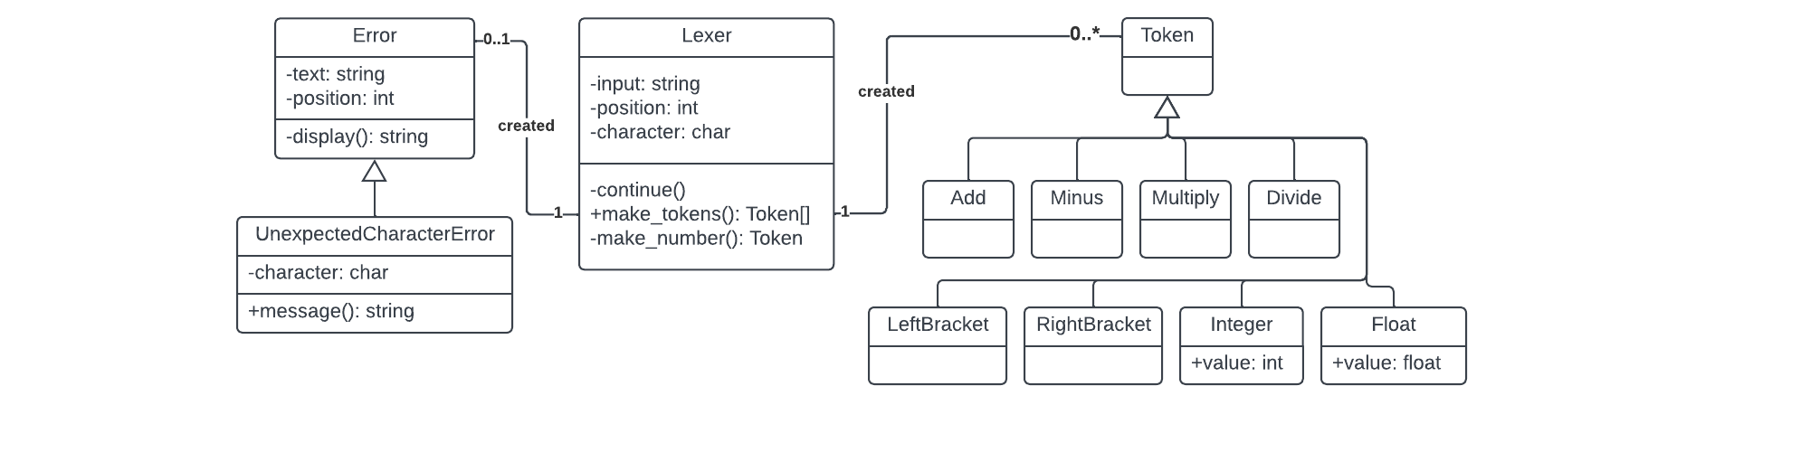For each phase of development, I am going to create a UML Class diagram which will represent the classes in the program which I will need to create, these are just a basis however, and may be changed in development to create new and updated features. The one for our initial lexer is as follows:

I will then go ahead and explain each new section that has been added.

### Lexer

This is the main part that has been implemented and will draw on the other aspects of the program. It has an input property, for the plaintext, as well as a position and character property which will cycle through the input string with the corresponding values. In the constructor, these will be given values and the continue() method will be called once.

🡺 continue()

This method will be called to advance through the input string, incrementing the position property and changing the character property to the corresponding value. However, if the end of the string has been reached, then the character will be set to null.

🡺 make_tokens()

This is the main method of the lexer and will comprise of a while loop which repeatedly runs until the character property is null. For each iteration, the current character will be repeatedly compared against characters, and then the corresponding token will be added to the end of a tokens list. At the end of each cycle, the continue() method is called to proceed to the next character, or if the current character did not compare anything, then an instance of an UnexpectedCharacterError is returned. Once all the characters are cycled through, the list of tokens is returned.

🡺 make_number()

This method will be called if the character in the make_tokens() function encounters a digit, because it needs to be handled separately. This will then continually call continue() and add the characters to an array until a non-digit is encountered. This excludes full stops, which will be added and will increment the value of a fullStops variable. When a non-digit is encountered, it stops the loop and the method will return an instance of an Integer or Float Token, depending on the number of full stops, with the value set as the array of characters type casted into a Number.

### Tokens

For now, these do not hold much code, but there will be a subclass for every kind of token which can be produced. The constructor methods will be empty, except for calling the parent class’s constructor so that they can be expanded upon later, as the whole point of implementing these now is to build a framework for later.

🡺 value

The only token classes with properties for now will be the Integer and Float classes, which will be set in their constructor methods so that they can be accessed.

### Error

This, again, is a base class which will be expanded upon in the future, which will take in the current line and the position of the error as an input in the constructor method. There will be a subclass for each more specific type of Error, for now only including UnexpectedCharacterError()

🡺 display()

This is a method which will be used for all Error subclasses, which will use the text and position properties and return a two-line string of the line of text with an arrow “^” below, which will be used to point to the position of the error, in order to provide useful error diagnostics.

#### Unexpected Character Error

This subclass will also take in the character which causes a problem in the constructor class.

🡺 message()

This will return a string with an error message describing the issue in English for the user to understand, with the display() method also being called so the position of the error will be shown below the error message so that a single method can be used to relay all the information that needs to be known about an error. In the future, all subclasses of Error will have a method called message(), to provide consistency so that an error message can be easily displayed regardless of the type of error itself.

# Development

I’ve had some experience with JavaScript in the past, but I still make a lot of small syntax errors, some of which I will be including, but a lot I will be excluding for the sake of conciseness.

## lexer basics

### character cycling

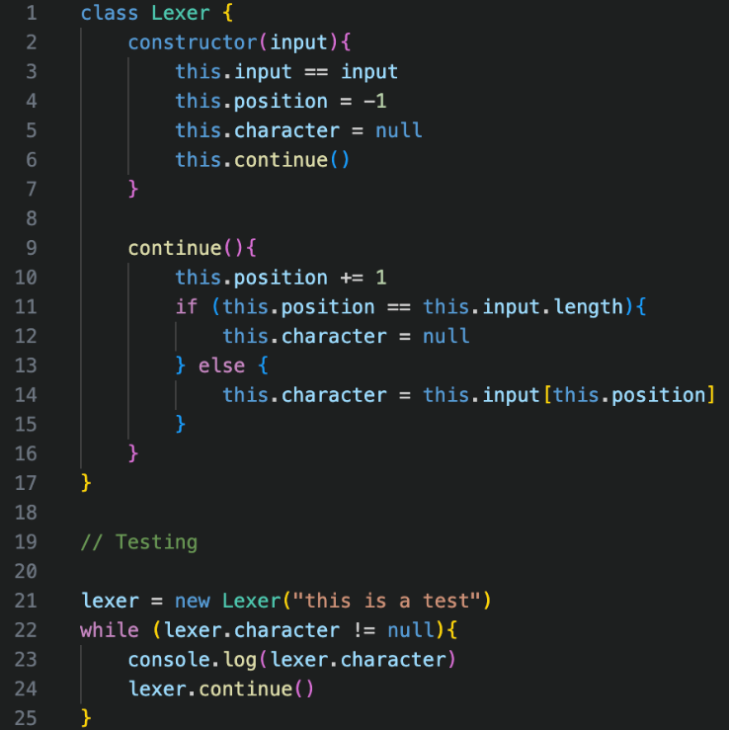I’ll start by creating our Lexer Class, which will follow the description in the design section. A lot of the time when writing a new section of code, I will do a quick test at the bottom of the file to ensure that it is working, and will sometimes show the errors, such as now, but a lot of the stupid small syntax errors I may include.



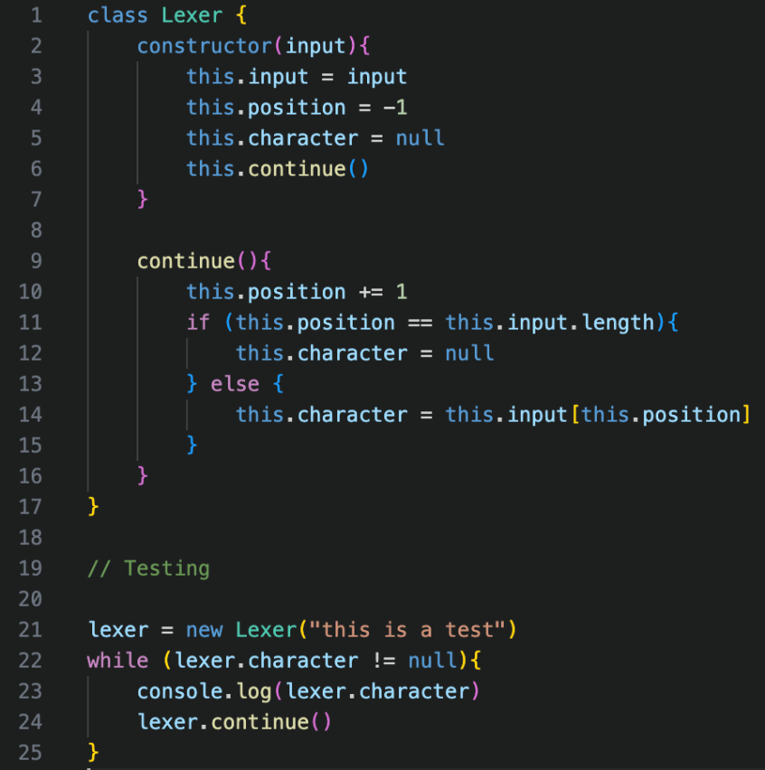This is one of those examples, where I accidentally used == instead of = in the token definition, which cause a runtime error. After fixing, it shows that the continue() function works as intended, and the output has been rotated for space saving reasons.

### Token Definition

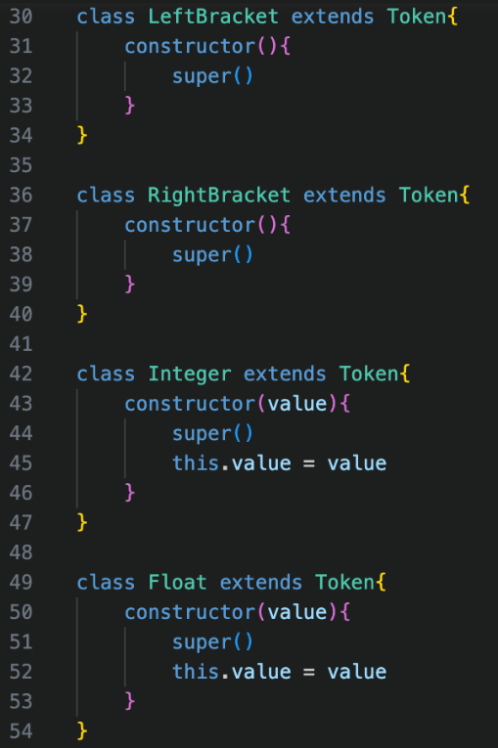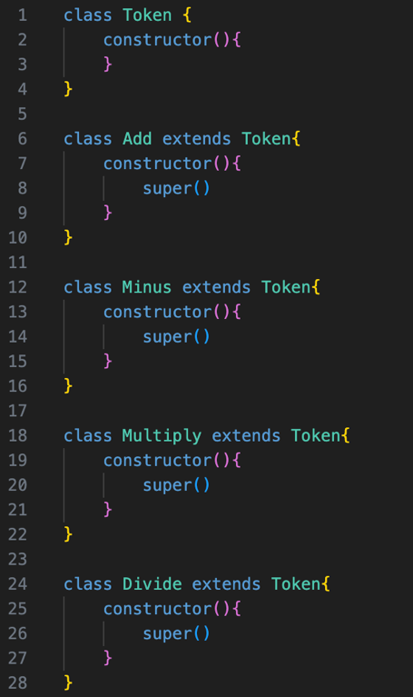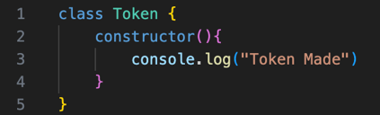Again, another straightforward implementation, with a temporary line being added for testing purposes.



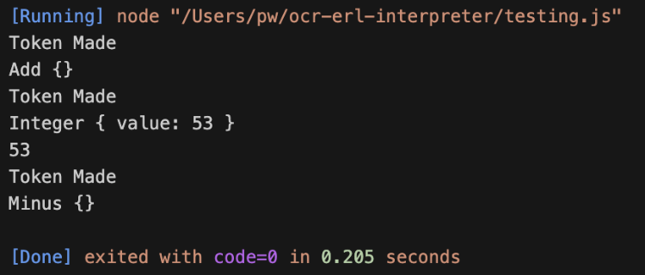

The intended values are returned, so therefore the tokens function correctly.

## Token generation

### Basic token generation

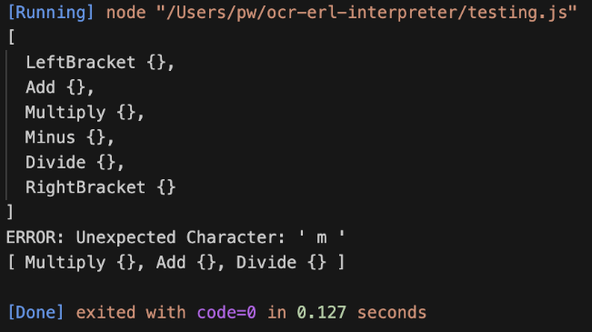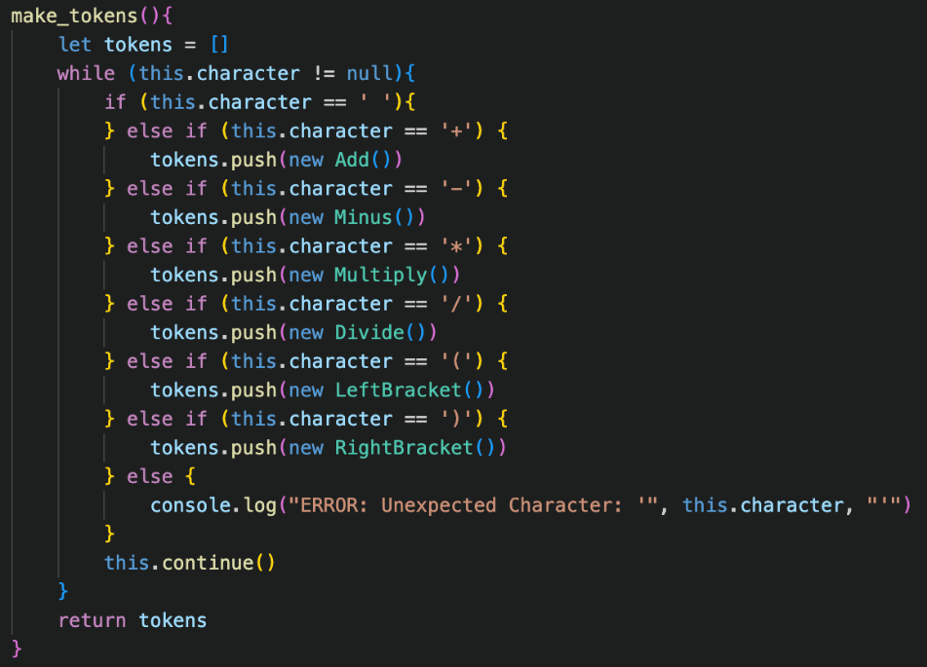All working, using a directly printed error message temporarily

### Number tokens

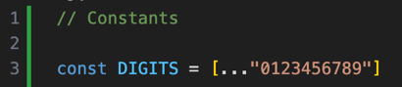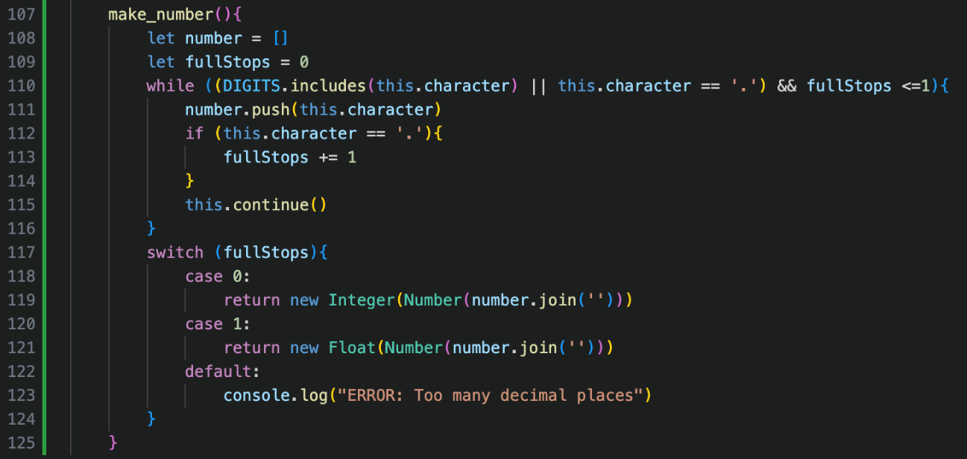DIGITS is declared globally as a constant so it can be re-used.

The make_number() method is added much like in the design description, but the while loop also checks about the number of full stops continually, so no unnecessary cycles occur when the number format is invalid.

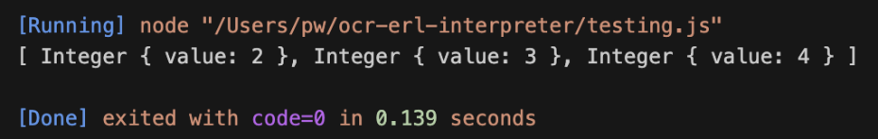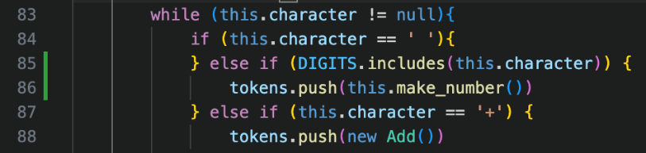The make_tokens() method is also changed, so that the current character is checked if it is a DIGIT, and if it is the make_number() method is called, and the value that it returns (an object) will be pushed to the end of the list of tokens.

When this new implementation was added, the output was incorrect. Somehow, only the integer values were included in the final result.

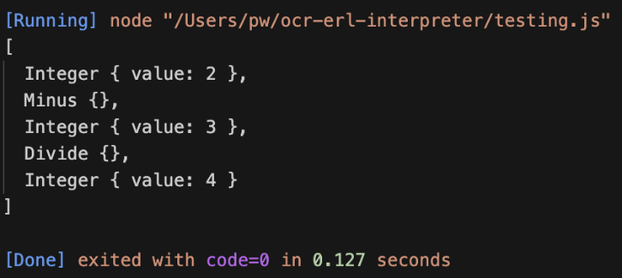This led to me doing a series of small tests to debug the error. My initial thought process was that something went wrong with the make_tokens() method with the new addition of the DIGITS checking, however, the following case of testing made me realise that the symbols could still be parsed, but it was just the character directly after the number that was skipped, which had to be something to do with the continue() method being called incorrectly, because only the symbols directly following a number were ignored.

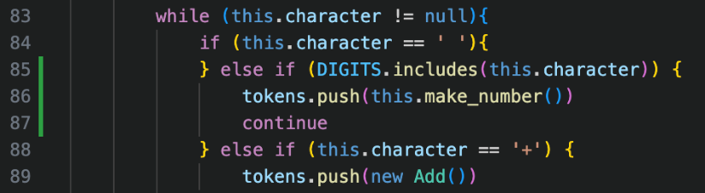I did then realise the continue() method was called twice after a number was completed, once in the last iteration within the make_number() loop, to check that the next character is not a DIGIT, but then it is also called at the end of a cycle in the make_tokens() loop, which therefore ignores a character.

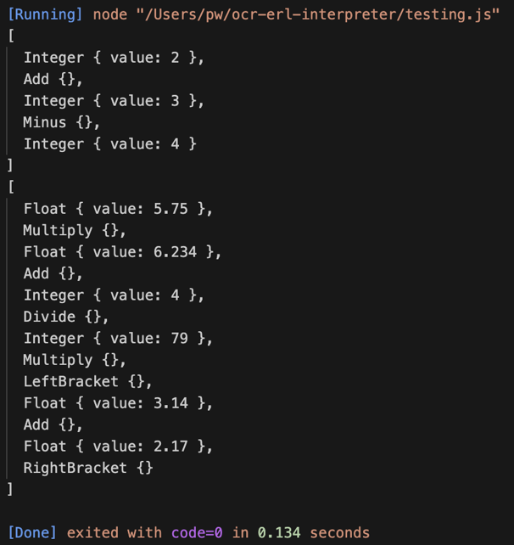The solution to this is including a continue statement in make_tokens() at the end of where a number is created, which skips to the next cycle of the while loop without completing the rest, which therefore ignores the continue() that will come.

Although not the cleanest solution, it avoids a lot of repeated code that would have to be included if continue was called individually in every other character check.

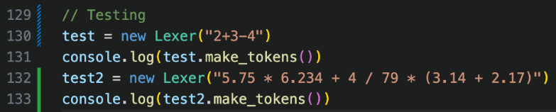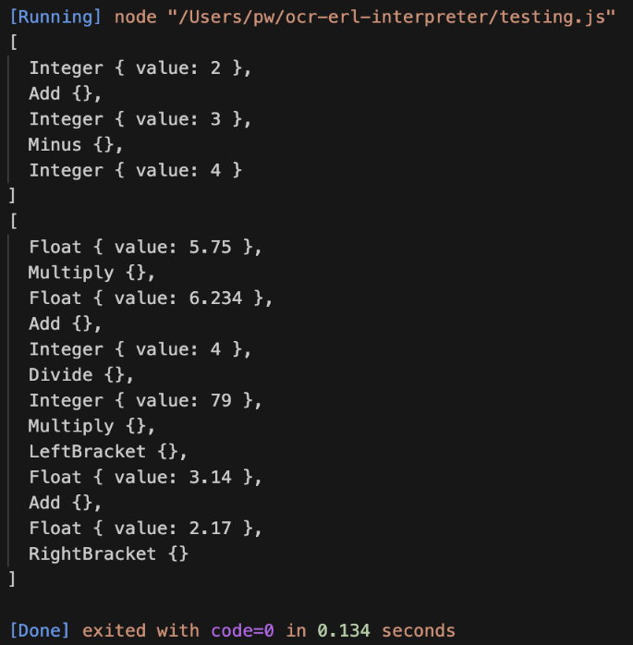Just to ensure the solution is working as intended, I completed the following tests and it was proven a success.

## Error handlIng

### Displaying Error message

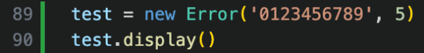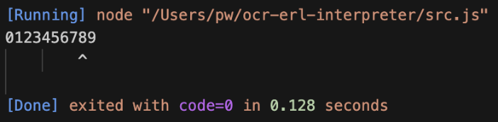This was my initial attempt at creating the display() method, which involved repeatedly adding a space to a list, and my test case expects the arrow to be pointing at the 5.

This is clearly very far off what is expected.

I first realised that using commas for string concatenation automatically adds a space to the string, which would add 2 incorrect spaces, so therefore + can be used instead, to remove this source of inaccuracy.

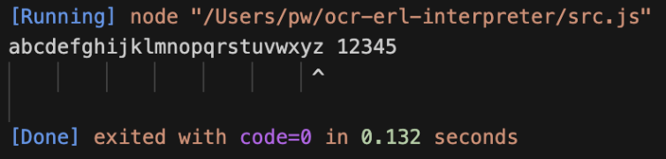However, this still didn’t fix the solution, as there was still one more space that had been falsely introduced, and this was because I used a <= comparison in the loop rather than using a <, so after this had been fixed and tested, it produced the correct result, and even worked with one, longer test just to be absolutely certain.

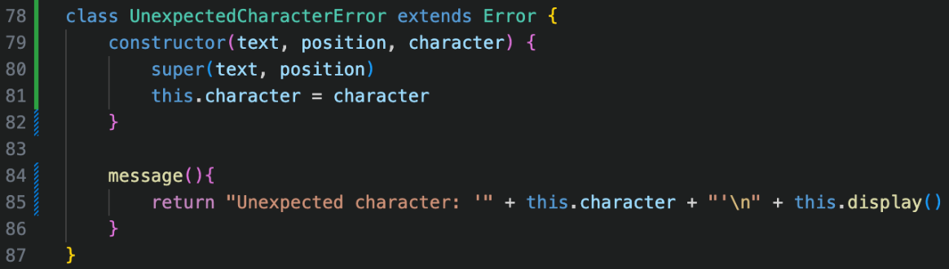

From there, creating the Unexpected Character Error class was very simple, and the test case correctly worked first time.

### Errors implementation

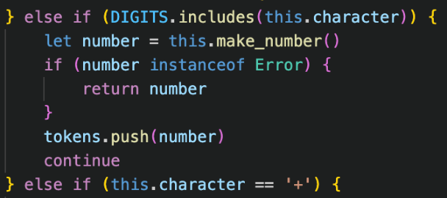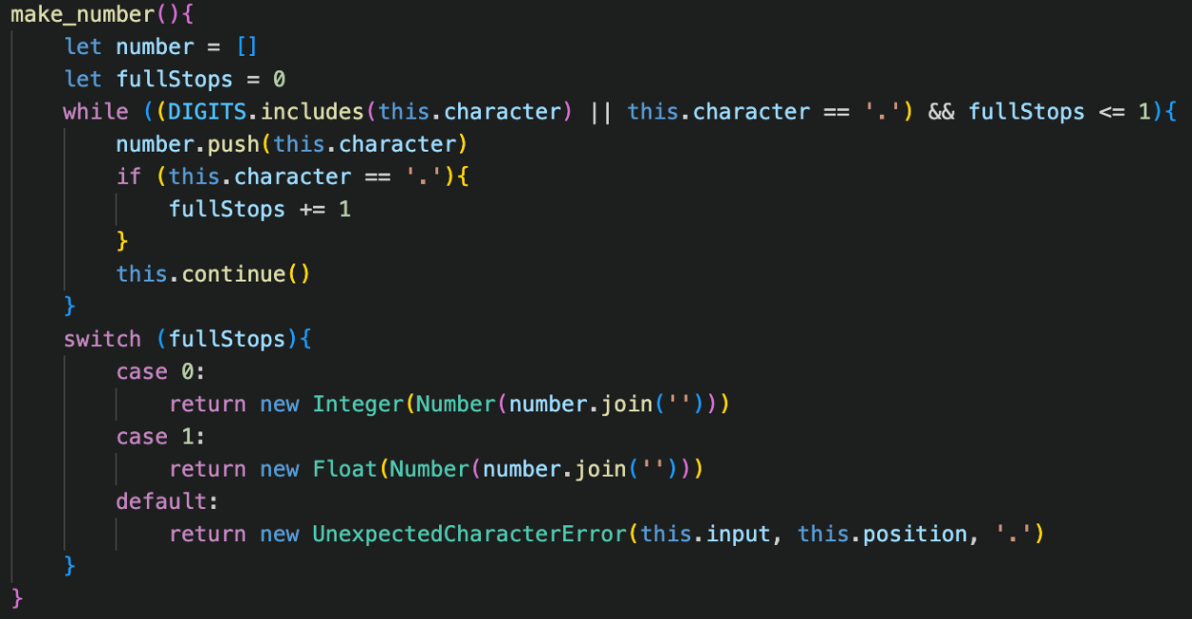Firstly, all the temporary Error print statements can be directly replaced by returning a new instance of the Error in make_tokens() and make_number()

However, when an error is returned in make_number(), it would currently just add the error to the tokens array, so we need to check if what is returned from make_number() is an error, and if it is we return that error in the make_tokens() function, which would stop processing, and otherwise we would just add the result to the end of the list as per usual.

For the medium-term, I have created a new Run class, which I am not planning to keep in the long-term solution. However, for now, it will be useful to link the different stages of lexing, parsing and code execution and will speed up the testing, as the whole sequence will not have to be rewritten, and can all be tested with one line.

We now must test all of the different types of errors to ensure that they work as intended.



Unexpected character errors work as planned, but errors with too many full stops in make_number() return the error with the wrong position. This could be fixed by changing the argument in the Error’s constructor method to this.position – 1, however I decided to refactor the whole code for the sake of it.

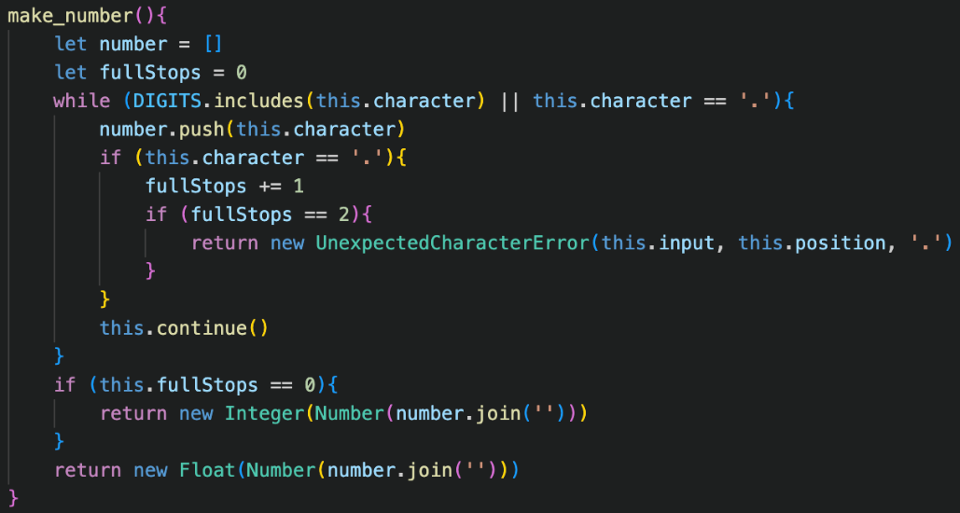This new method no longer includes checking for full stops in the while clause, and instead does it inside of the checking for full stops if statement, where the error is directly returned then, rather than after calling continue so the position will be correct.

It works properly now.



It is still important to check that it works without any errors at all, and it turns out that the new make_number() had a small syntax error (writing this.fullStops instead of fullStops), showing the importance of re-testing, which allowed me to correctly restore the function of the program.



## Cleaning Up

Although I have now added all the features that I want for this stage of development, I think it is important to come back and refine previous code, adding commenting and making improvements so that I don’t get as confused when I return later in the development process.

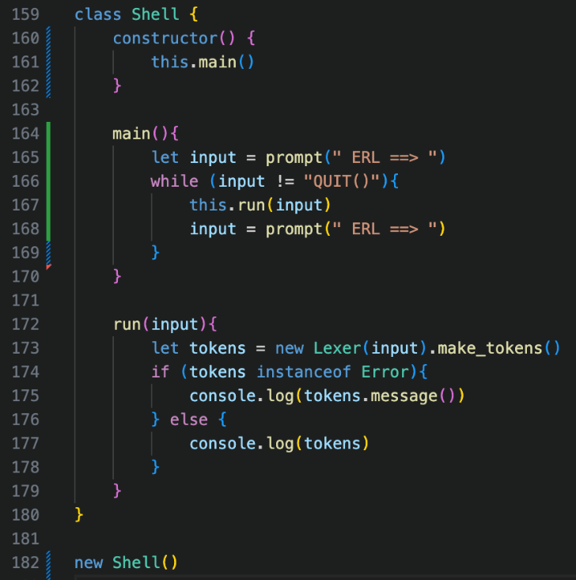I firstly changed the old Run class into a new Shell class, which I planned to be an even easier version to use, which would make testing significantly easier for the rest of development, by taking a direct user input.

My lack of experience with NodeJS began to show, as it took a very long time for me to find a working user input, as my first two attempts completely failed, and some methods used techniques I was not comfortable with, such as asynchronous methods, which I felt were a bad idea to use as I would have no idea how they worked, so I decided to use prompt-sync for inputs.

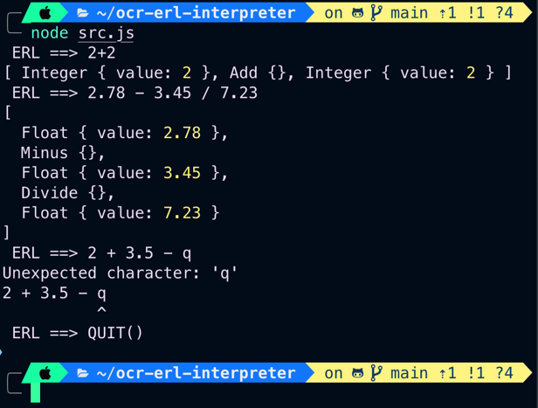

This is, again, a medium-term solution, as the final version will take the user input in graphically on the website page, but for the development of the translator it will work, and I have decided to use an arbitrary “QUIT()” input to exit the program.

In further research of JavaScript shortcuts, I discovered template literals, which are an easier way to concatenate strings, much like the f-strings of python but requiring a $ sign, which I implemented into Error messages for greater readability, and tested.

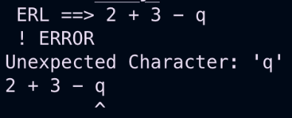Additionally, the repeat method saves needing counter-controlled loop in the display() method of the Error Class, which simplifies the code significantly. I also tested this to ensure it still correctly worked.

The next useful feature is the conditional ternary operator, which can be used within JavaScript with an expression ? statement : statement syntax. It is the equivalent of checking if the expression is true, and then returns the first statement if it is true, or the second if it is false, and removes redundant if statements.

For example, I used it within the continue() method, to check if the position is equal to the length, which then sets the current character to null if true, or the corresponding character if false.



Other examples include in the fullStops statement, to check whether to return an Integer or a Float, as well as checking if what has been returned from the Lexer is an error, so the Shell instance can output either the object or the message property of the object if it is an Error.



Bodmas parser

# Design

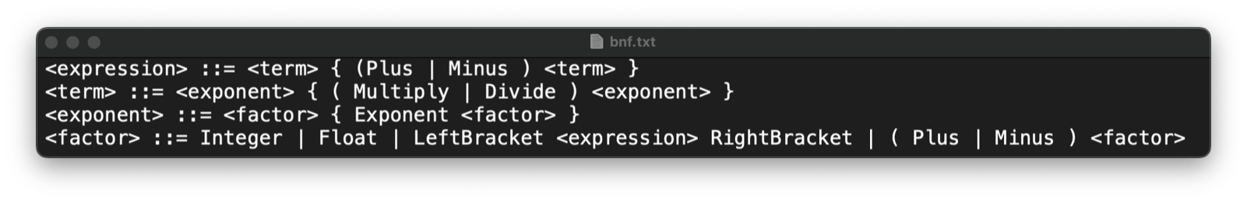

The BNF for our parser is slightly different to our simplified version from earlier in the overview.

This is slightly more complex, but before we go into the details alongside the UML class diagram, we need to go into more depth about how the parsing algorithm functions on a code level.

## The complexities of parsing

In our previous example, we thought of parsing being constructed from the bottom up: from <term> to <factor> to <expr>. This process occurs the other way around, using recursion, from the top down, with <expr>s constructing the <factor>s, which make the <term>s.

In our code, we will have a different method for parsing the expression, the term, and the factor, each of which will call upon the next. The important point here is that they are all members of the same object. The required tokens aren’t passed as an argument to the next method, but the character property, in conjunction with the continue() method are used.

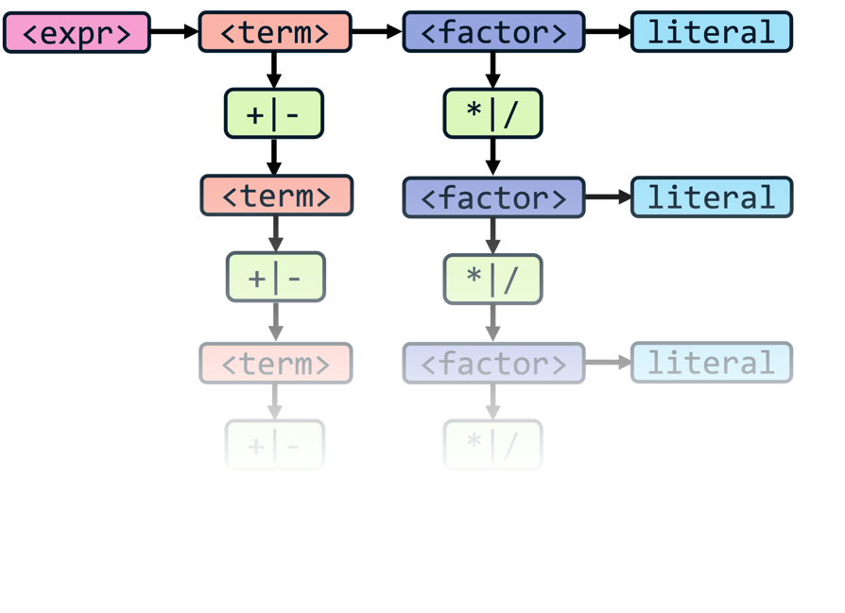This means that, after one method has continued parsing, you can call it again and the current position and character are maintained. So, for each method, the next method is called, and then it is checked if the next token is one of the corresponding operators. If it is, then the next method is called again, and the process repeats: checking if the next token is corresponding, and then calling the next method.

🡺 This sounds complicated, but it is easier to use examples. For example, the expression method calls the term method, then checks if the next token is a + or a -. If it is, then the term method is called again, and this repeats. Likewise, the term method will call the factor method, and then check if the next token is a * or a /. If it is, then the term method is called again, and this also repeats.

I think this diagram is useful to visualise this repeated pattern, because that is the best way to thinking about it: a long chain.

It is also now important to visualise the code itself. Diagrams are important to visualise the overall structure but explaining it in pseudocode helps to bridge between the logic into the code itself.

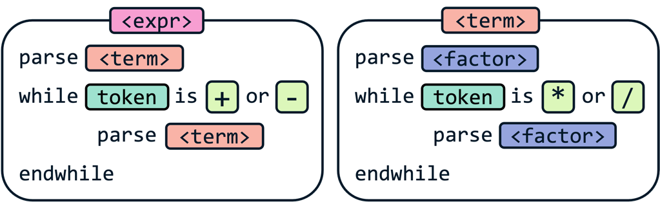This is the same concept in a different form factor, but a very overly-abstractified version of the real version. It is crucial to understand this fundamental format however, as it will be repeated and used in some equivalent throughout the entire program.

The concept that took me the longest to understand is that it is the equivalent of filling in the gaps, and that each time the next method is called, it is “completed” and that – as long as there are no syntax errors – the next token will definitely be a +, or a -, or the end of the input has been met.

This level of decomposition makes each stage of parsing by itself simple, by abstractifying away all the complexities behind it. However, this incorporates our two main principles of parsing. The precedence is maintained by having the first method to be called being the most general one, with the lowest priority operators, and each following method that is called is more specific, with higher priority operators.

The associativity is also maintained, which is logical as the while loop in each method goes from the leftmost token to the rightmost, ensuring that the correct order is maintained, however this makes more sense when we develop our methods slightly more.

### Construction

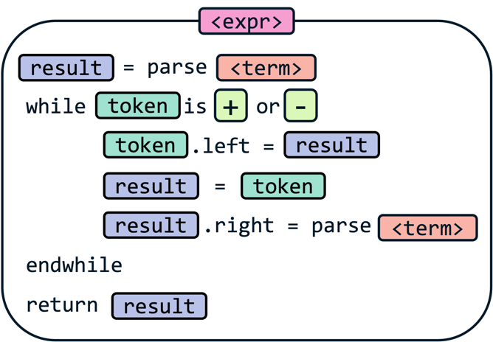Now that we know in which order we build our tree, we must actually construct it.

The basic pseudocode is as shown, and it takes the current token, and sets its left and right to the result of the next stage of parsing. In this case, the expression method takes the first + or -, and sets its left and right property to the result of the term method for the tokens on the left and right of it.

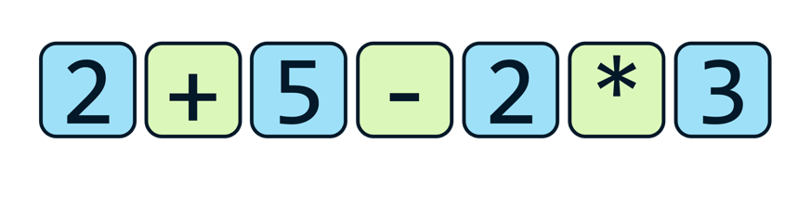From here, if any more iterations occur with new operator tokens, the left property of that token is set to the previous operator token, and the right is then set to the next stage of parsing, continuing from that point.

That was not a very succinct description, but again, examples are useful.

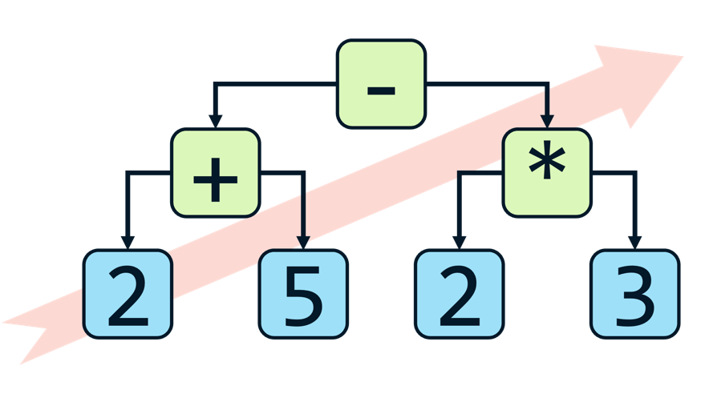The expression method is called on this stream of tokens:  
🡺 The term method is called and returns an Integer with value 2  
🡺 The current token is a Plus, and its left property is set to an Integer with value 2  
🡺 The term method is called again and returns an integer with value 5  
🡺 This result is set as the right property of the Plus token  
🡺 The new current token is a Minus, and its left property is set to the previous  
 🡺 This means its left property is now a Plus token which has two Integer children  
🡺 The term method is called again, and now returns a Multiply Token  
 🡺 This Multiply Token has a left child of Integer 2 and a right child of Integer 3  
🡺 This Multiply Token is set as the right child of the Minus token  
🡺 There is now no new current token so the expression method is complete and returns the Minus

As you can see, this results in this abstract syntax tree being formed, which is built from the bottom-left to the top-right. It is good to try and visualise each one of the steps as this tree expanding, with each arrow in the diagram being one of the child properties of the parent set to the child.

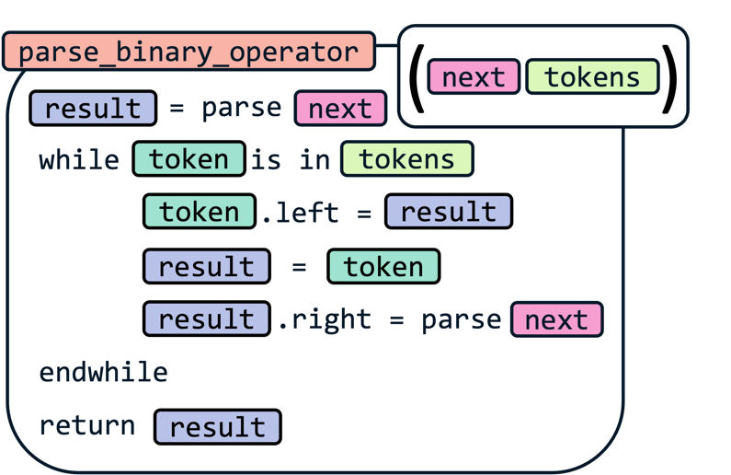Finally, it is worth thinking about how this solution can be generalised, to reduce code repetition as a whole, so the following is adapted to take in additional arguments of what the next parsing stage is, as well as which tokens are corresponding to this stage of the parsing.

Now we have built up a foundational understanding of the parsing process, it is important to see how this links back to the whole program as a whole, as we return to our UML diagram.

## Integrating parsing

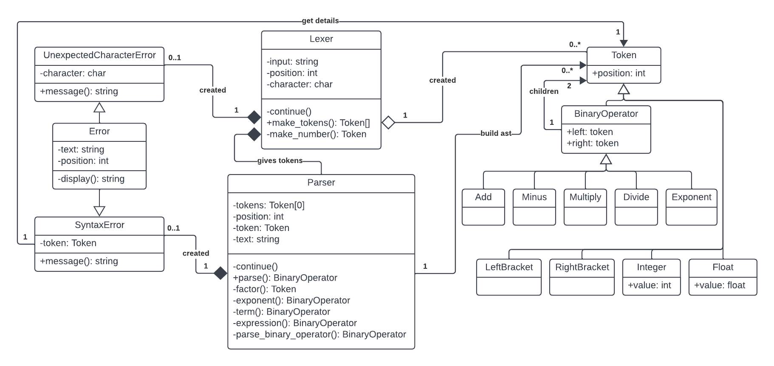Now let’s get back to our implementation and have a look into how our properties will allow us to parse according to our BNF rules.



### Token updates

No huge updates in terms of new code, but mainly additions of small features:

🡺 Position attribute given to all Token classes.

This allows for error handling to still use the display() method in the parsing stage.

🡺 Binary Operator class is a parent class of all arithmetic classes.  
🡺 All Binary Operator classes given properties for left and right child nodes.

This allows us to construct abstract syntax trees using the Tokens, but it is the new Parser class which changes these left and right properties to the correct values.

### Errors

The addition of a new Syntax Error class for the Parser to use. This will take in the parameters of the text and the token which caused the error to occur. It will use the position property of the token for the display() method, and the new message() method will be updates based on the token which flagged the error.

### Parser

The main addition. In its constructor class, it will take in the stream of tokens from the lexer, which will be stored in the Tokens’ property, as well as the original text, stored as text, to be passed to any syntax errors that occur so the correct message will be displayed.

It will also include a position and token property, which are direct equivalents of the position and character properties in the Lexer, allowing us to cycle through the tokens and keep it consistent.

🡺 continue()

Again, replicated from the Lexer, incrementing the position on each call, and setting the token property to the corresponding token in the tokens list. This will also set the token to null if the length is exceeded.

🡺 parse()

This is the main method to be called, which will return the Token which is at the top of the abstract syntax tree. This token will therefore contain every other token as its children and grandchildren, and the result will be used in the final stage of code execution. Additionally, it may also return an Error if any problems occurred in the parsing process.

In the future, this method will also recognise which “type” of line the code is. For instance, whether it is an assignment, an if statement, or just an expression. It would then call the corresponding method for whatever is required. However, for now, it will call the expression method, as we are only parsing arithmetic expressions, so this is the correct method to call, and will return its result.

Finally, after the expression() method has been called, if the current token is not null it means that the entire stream of tokens has not been parsed, meaning that there was an error in the syntax. In this case, it would mean that there were two literals in a row in the expression, as otherwise the expression would be able to be continually parsed, so therefore a Syntax Error is returned, with the current token being passed into it.

🡺 parse_binary_operator()

This is our generic property which we discussed in our explanation. Therefore, it takes in the next property to be called and an array of the corresponding tokens. In addition to this, we will require error handling to be implemented throughout the parser.

The way I will deal with errors is that every time the next property is called, I will check if what it returns is an instance of an Error. If it is, only that will be returned, rather than building the error into the abstract syntax tree. Therefore, if an error occurs at any stage of the parsing, it will be passed up through all the stages of parsing, back to the parse() to be returned. This means that every time a different method is called in our code, we will be checking if the result is an instance of the Error class a lot of the time.

Apart from that, this method works exactly as we expected, but also calls the continue() method in the correct places, as I decided to abstractify that detail in the example to make it simpler.

🡺 expression()

Calls the parse_binary_operator() method with the next method parameter being the term() method, and the array of valid tokens being Add and Minus and returns the result. This is the equivalent of the <expression> line in our BNF.

🡺 term()

Calls the parse_binary_operator() method with the next method parameter being the exponent() method, and the array of valid tokens being Multiply and Divide and returns the result. This is the equivalent of the <term> line in our BNF.

🡺 exponent()

Calls the parse_binary_operator() method with the next method parameter being the factor() method, and the array of valid tokens being only Exponent and returns the result. This is the equivalent of the <exponent> line in our BNF.

🡺 factor()

This stage is more complicated than the prior stages, as there are a few different cases in our BNF representation, as it as a more complex line than the prior.

Firstly, we check if the current token Is either an Integer or a Float, and if it is we return that token, as a <factor> can be either an Integer or a Float

Secondly, if the current token is a LeftBracket, then we continue() past it and call the expression() method. This is important as it ensures that any arithmetic inside of brackets is executed first. After the result is obtained and checked for errors, it is important to make sure if the next token is a RightBracket. If it is, then continue() is called and the result from expression() is returned. This removes the brackets from the AST, as they do not hold any value apart from indicating the precedence of the operations. If the next token is not a RightBracket, then an error has occurred and must be created and returned.

Later on we will need to also include unary operators into the factor() segment, but as to not add too much functionality at once I have decided to add that later in order to focus on the main elements.

# development

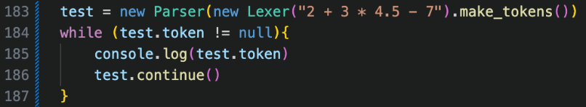Copied from the Lexer, works as intended with the test.

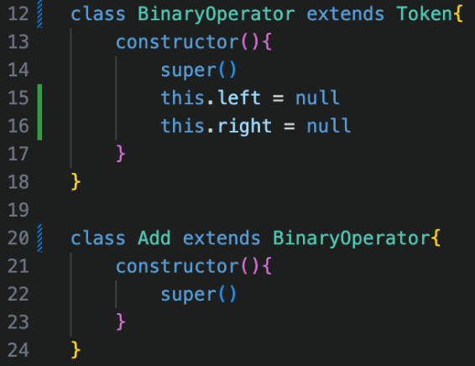

Added the Binary Operator class which extends Token, and then changed Add, Minus, Multiply and Divide to extend it as well. This just reduces code repeating.

Then began implementing the expression() method, which will use the following code for every single test that I do, so the end goal is to have an Add token, with the left child being an Add token with 2 Integer children of 2 and 3, and the right being an Integer 4.

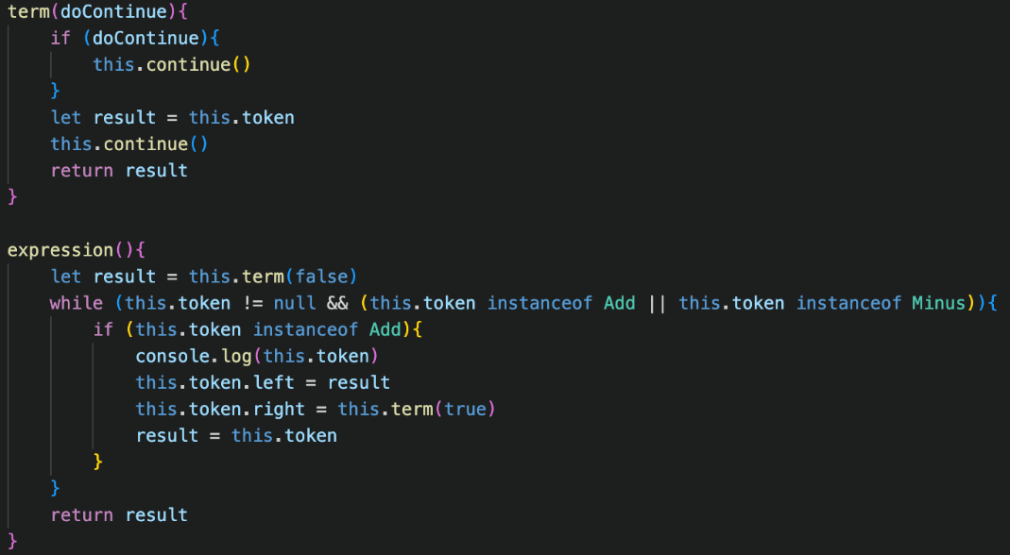

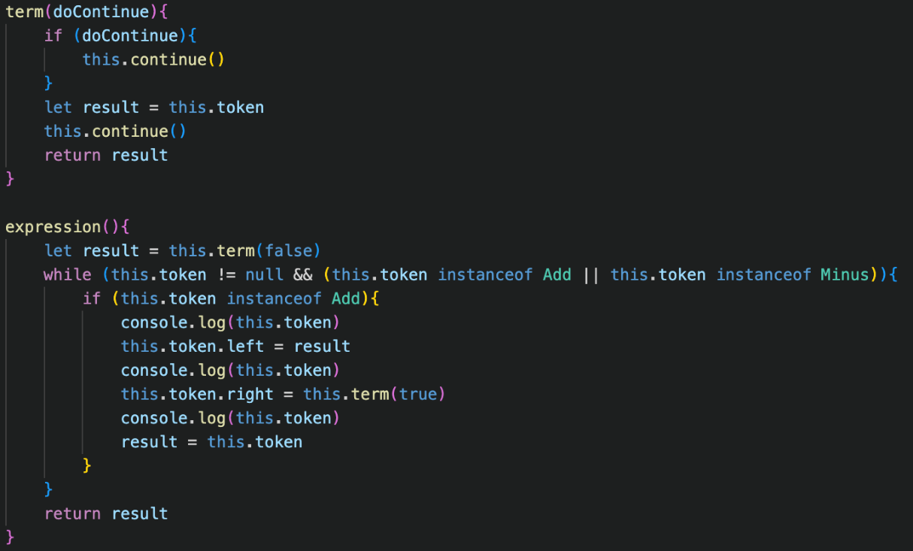This was my first attempt at getting the parser to work. My initial thought behind the doContinue parameter is that I would not have to create additional variables to save the current token to before using the continue() feature. This was, with hindsight, a very messy implementation, but at the time the term() method was only temporary so I thought I would come back later and alter it.

Regardless, when trying to run the console didn’t output anything so it was non-functional.

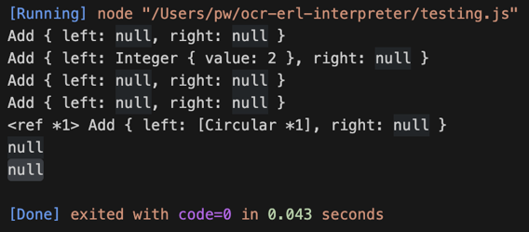When trying to add output statements to help to debug, it was very clear my code did not work, but this output didn’t help my thought process much: the <ref *1> and [Circular *1] completely confused me so I then decided to add even more output statements to the term() method to see if that would provide any more insight.

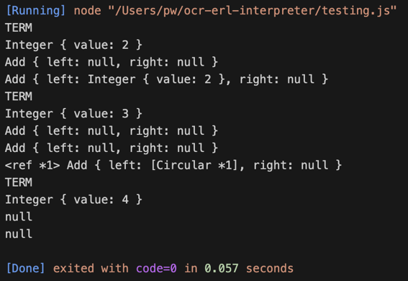Adding this made me realise that the first element of the process worked: with the term being correctly yielded and set as the left child of the Add, however when the send term() was called, the Add token suddenly had removed the left child and the right child and they were both back set to null like before.

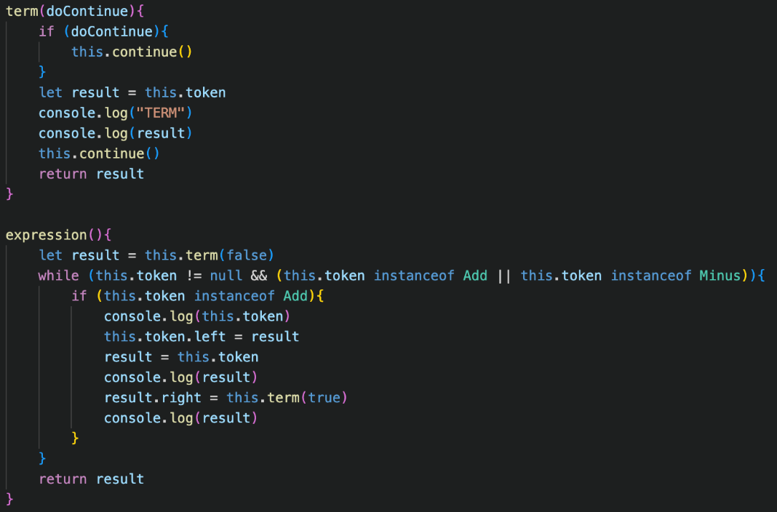However, this would not have been possible, so the issue was that the program had already proceeded to the second + node, and continued from the first which revealed the main problem: using this.token was not the correct approach for changing the properties of the Add node because it would change when the other properties were called due to the object-wide nature of the continue() function.

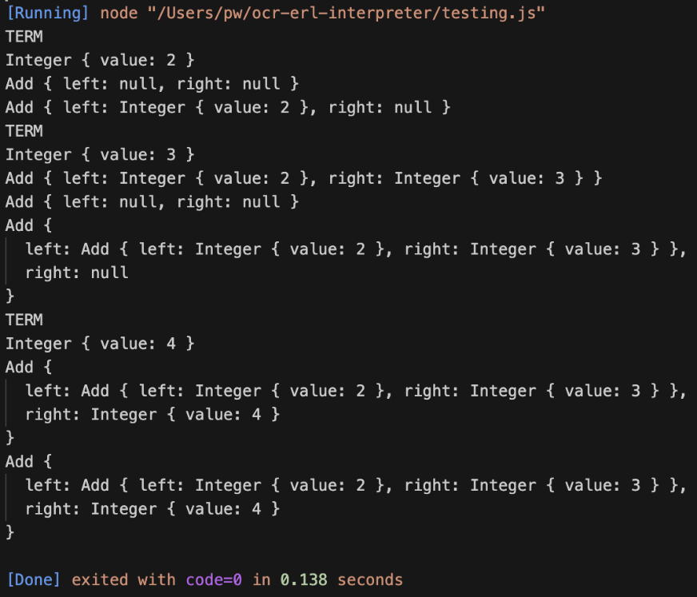Therefore, I would be forced to re-use the result variable throughout the program to ensure that I was modifying the correct token’s properties, and when changing the output statements to correspond with this, the program produced the expected result.

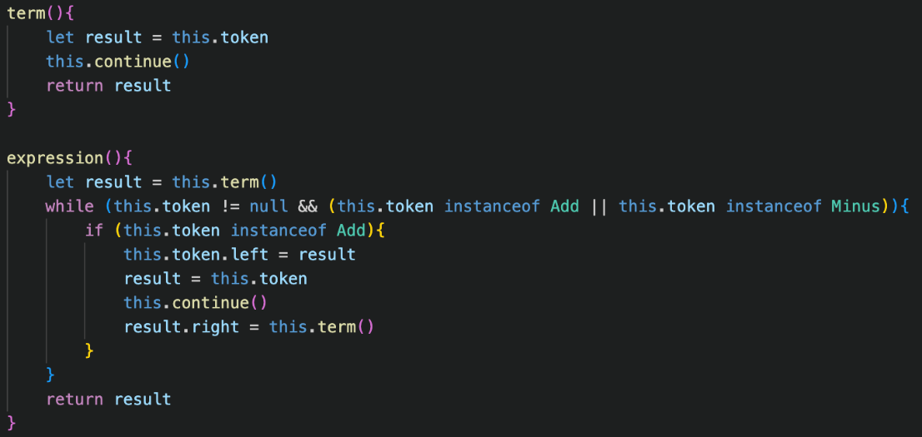From there, it was a matter of removing all of the output statements and therefore the code still worked as expected.

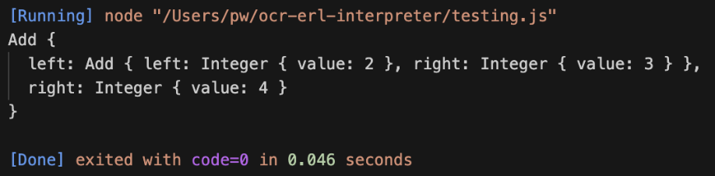Furthermore, I also realised I could further remove the messy doContinue implementation, as the fact that the current token was stored in the result variable meant that I could implement the continue() call in the expression() method rather than at the start of term(), which significantly cleaned up the code and still produced the correct abstract syntax tree.

## OTHER OPERATIONS

Now I needed to add the three other arithmetic operations

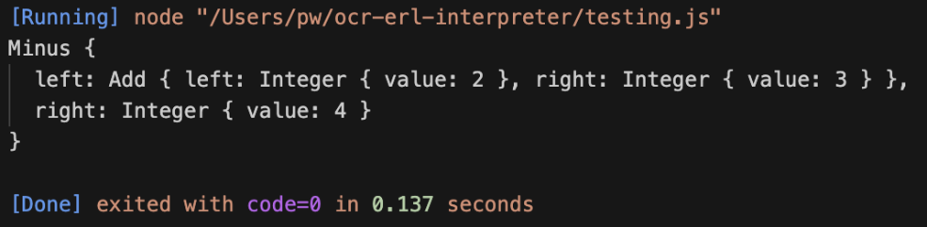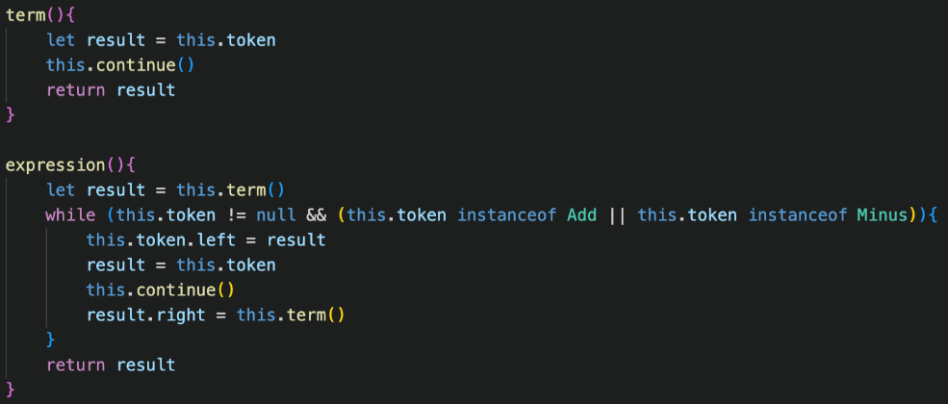This was extremely straightforward and even helped to modify the code from earlier, as I realised that that if statement which checked it the operator was a Plus or a Minus was completely redundant, as the same step of operations would be carried out regardless of the type because they had identical precedence.

This further simplification allowed the code to work for both addition and subtraction.

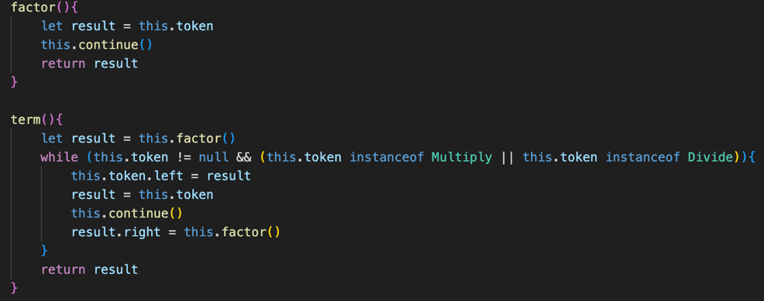From here, adding Multiplication and Division was a matter of duplicating the code from expression() into term(), and changing Add and Minus to Multiply and Divide. Finally, the old term() method was renamed to factor(), and from there it correctly builds the abstract syntax tree.

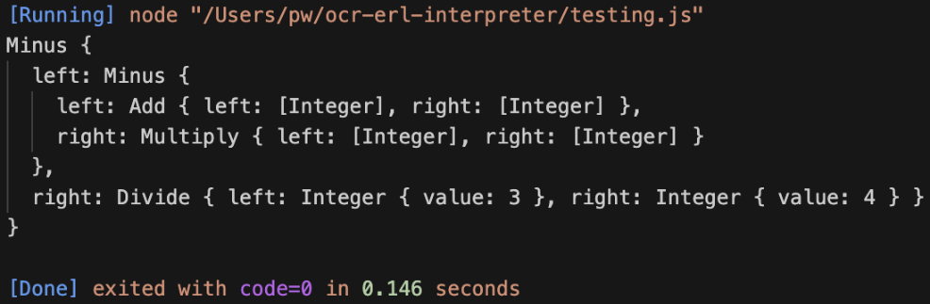However, this is a lot of repeated code, because the expression() and term() are identical apart from the next method and tokens accepted, so the next stage is implementing the generic method which will be able to make our code a lot more efficient.

## generalising.

This new method was not involved in the plan, but I thought it would help improve the code readability. It will be used in the parse_binary_operator() method, and it takes in an array of classes. It then checks if the current token is an instance of any of the classes and returns true or false accordingly.

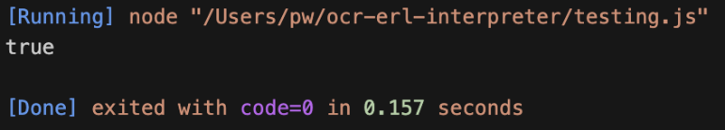It will be clearer when we implement the main method as to how this is used, but for now the test performed as expected so I continued to develop the generic method.

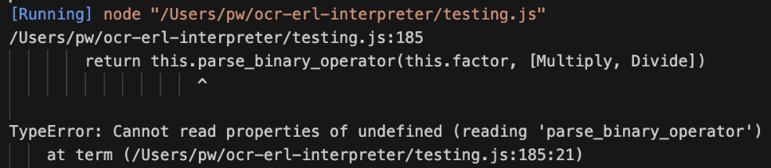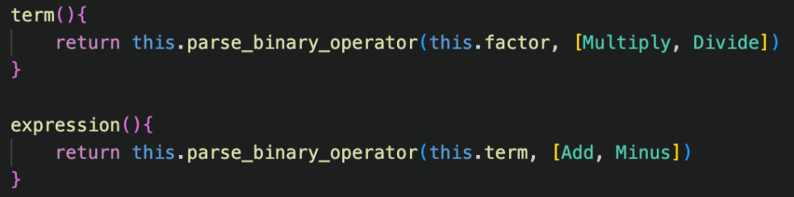The first trial was again, duplicating the code from the original expression() method into parse_binary_operator()

I decided to name the parameter for the next method nextFunction, which is potentially slightly inaccurate naming (nextMethod may have been better), but it still relays the meaning of the code.

This is where check_instance() comes in, as we pass it the correct tokens to cycle through, so for expression() it is Add and Minus, and for term() it is Multiply and Divide. It is essentially the same as the old or statements that were in the old examples however now it works for a list of tokens of any size, and the separate method makes the code a lot easier to read.

Now we can replace the old term() and expression() methods by making them simply call the parse_binary_operator() method, with their corresponding values.

However, instantly an error occurred, with the message saying that parse_binary_operator() was undefined. At first, this confused me, but after some debugging using lots of output statements, I realised that the problem was not with the method itself, but the this keyword in JavaScript.

The this keyword represents the instance of a class in JavaScript, so it can be used to access all of the attributes and methods easily without having to worry in the code about the current instance. However, this is not specific to only classes, but as JavaScript is an object-oriented language, what this references changes based on the context. This was a problem in our case, as when we began calling methods through methods in the way we have, the definition of this managed to change, so that it no longer referenced the instance of our Parser, but instead referenced one of the methods, which had no parse_binary_operator() method associated with it specifically.

This may sound like a complicated fix, but the solution was to replace this with a different identifier which we knew would always reference the parser itself. My approach to this was using self, which would always reference the parent parser, and would be passed as an argument to all of the different parsing methods to ensure consistently arose.

This is how the implementation occurred in the parse_binary_operator() method, with all of the this keywords being directly replaced, alongside a new parameter which – for code consistently – I will always keep as the first parameter for methods which require it.

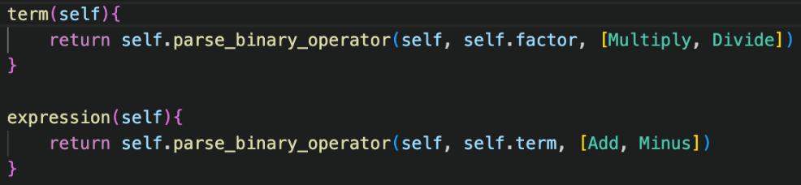This new self-syntax would also have to be used in the term() and expression() methods, in order to ensure that the instance of the Parser could always be reference and is passed down through the stages.

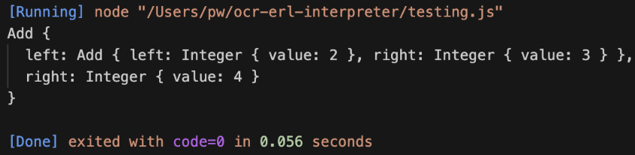The way that self is initially defined is in the new parse() method, which calls the expression method normally, with the argument being this: referencing itself to be passed down throughout.

This may not be the cleanest implementation of this, but it worked so I have used it from this point onwards for the rest of the program.

## Exponents

The whole purpose of constructing our code in this style is so it is a foundation for the future and can be easily expanded to include new features into the interpreters, such as exponents.

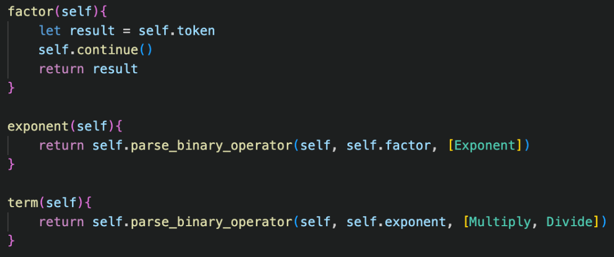In order to add them, firstly the new class must be defined and extend the Binary Operator class, and the make_tokens() method must be extended to include a new line which adds an instance of the Exponent class if the corresponding character “^” is encountered.

From here, as exponents have a higher precedence than multiplication and divison in bodmas, the exponent() method can be added, with the nextFunction being factor(), and the valid token being Exponent, as expected, in an array format as that is needed for check_instance()

Finally, the term() method must be changed to call exponent() instead of factor(), as it has a lower precedence so must call upon it before factor(), as stated in our BNF implementation of our code.

Running a simple test immediately works, without any errors at all at any point in implementation. This shows the positives behind constructing our code in this format, as it is incredibly easy to expand as our approach has been so generalised as to allow for this to occur.

## Brackets

Now that the other lines of BNF have been implemented, it leaves us with the factor() method to work on, for now I will be ignoring unary operators and only implementing the bracket handling.

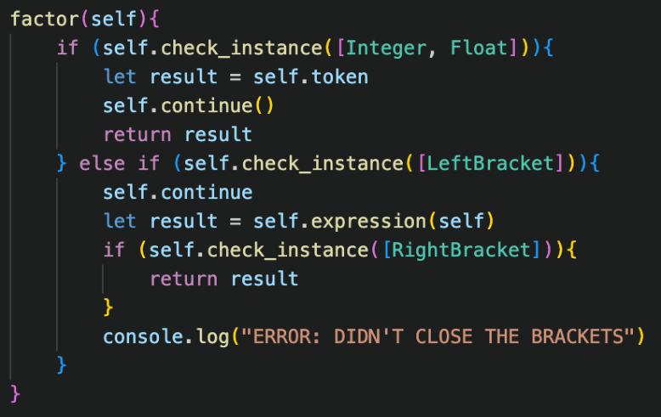My first attempt of implementation matched the description in the design phase. The new Left Bracket check had a temporary outputted error message if the token after expression() was called was not a Right Bracket, to be changed later.

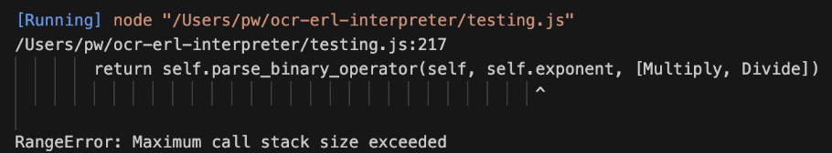However, when trying to run a test, a Range Error occurred stating that the maximum call stack size had increased. This confused me at first, and then I decided to add output statements to the factor() method to see if they would help with debugging.

Again, the same error, but it showed that the program got forever stuck on the Left Bracket token, which made me realise that my continue call was forgetting the () afterwards, which meant that I could not continue past that token which caused this recursion.

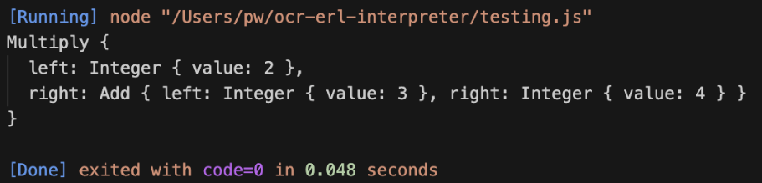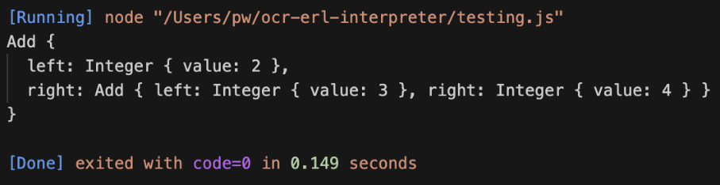

With this being fixed, the test case then worked. The other test cases I thought were important were a case for brackets in the middle of an expression, a case where the brackets were never close, and finally a case with brackets being inside other brackets.

The first case did not work, as after the brackets had close the rest of the tokens were ignored, so the to the power of 7 was excluded from the ast.

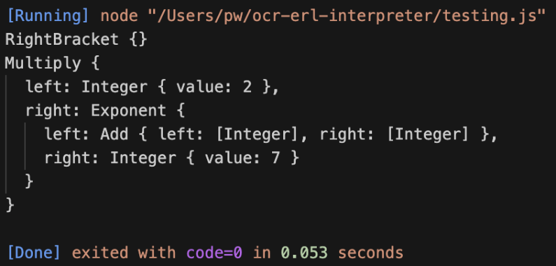After some debugging with output statements, I realised that the problem was that continue() was never called to proceed past the rightbracket, so after that was added the program functioned correctly.

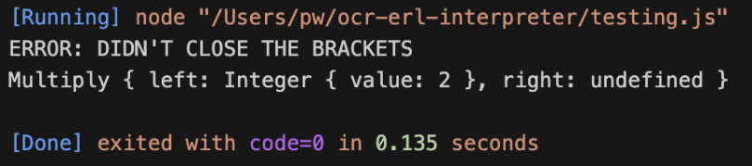Next the non-closed brackets test case was checked, and it correctly outputted the message. Later this will be improved to not also return a half-completed AST a with better implementation.

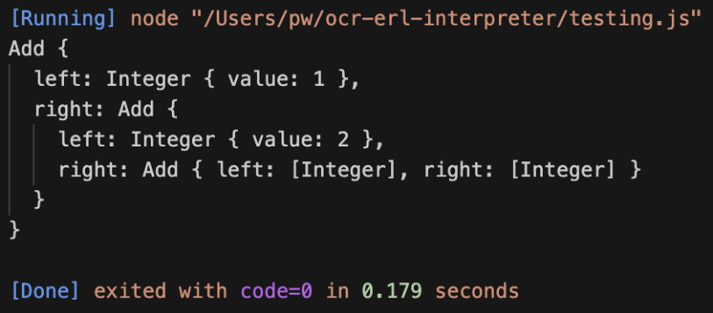Finally, the test case with brackets inside of brackets worked perfectly first try, because of the nature of our recursive implementation.

This now completes the implementation of brackets, with only unary operators required to be added in order to complete the BODMAS parser

## Error handling

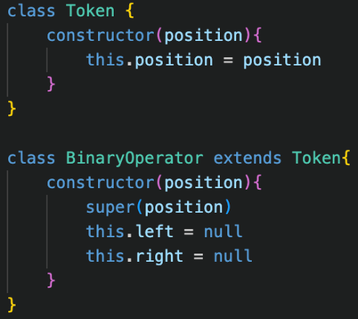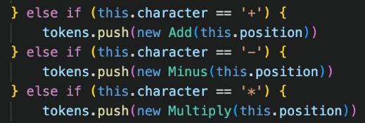As you can see, currently if the input string has invalid syntax, the Parser returns an attempt at a broken abstract syntax tree, rather than reporting an error, which is what the next stage of implementation is going to be, with unary operators coming later in the process.

The first stage is adding a position property to all token classes, which is needed for the display() property in the Error class to point to the error.

Because the position property needs to be given on creation of the token, this needs to be added to the Lexer. Therefore, in the make_tokens() method, the Lexer’s current position is passed into the constructor of the tokens, so therefore the position corresponds correctly with the plaintext, rather than other methods which may cause issues with whitespaces.

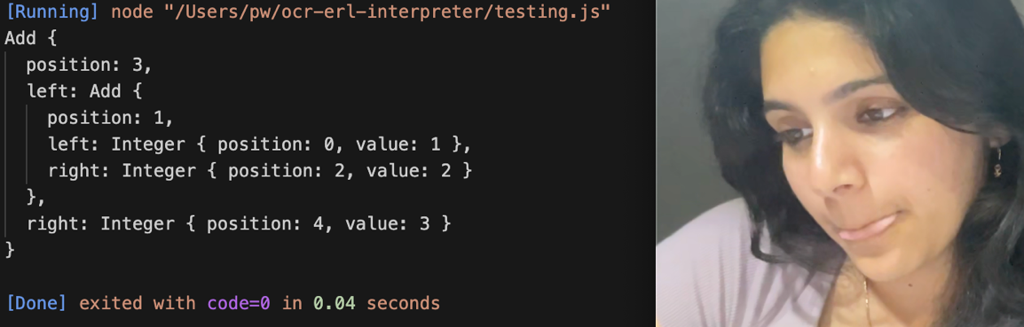For tokens which take up more than one character, I’d like the position property to correspond to the position of the first character, so therefore for the make_number() property, we will have to assign the position to a variable at the start of the property before using continue() so that it is correct, and then use that variable for the construction of the Integer or Float, as shown in the code below.

Just to check that this is correctly working, I ran a quick test and all the positions were correct in the abstract syntax tree.

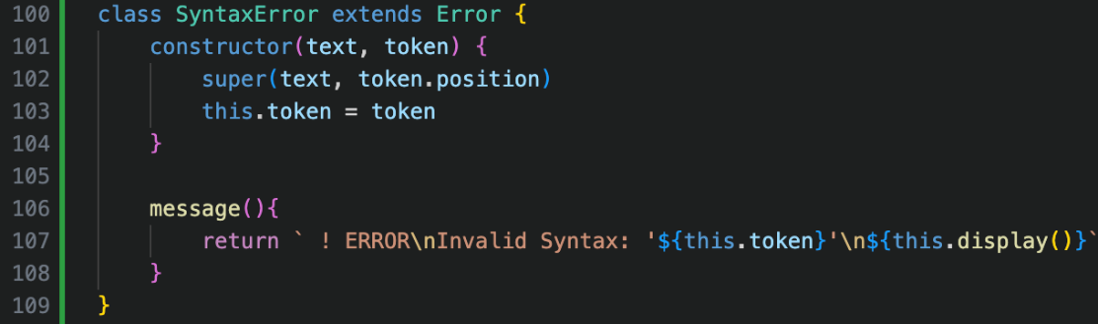Now we can create our new Syntax Error class, but this accepts a token and the text as an input unlike the others.

The position property of the token given will then be passed to the super() call so that the Error’s position can be assigned.

The custom message() for syntax errors has also been added, with the same identifier so that any error can easily be called.

To implement errors, the Parser’s constructor must take in the plaintext input.

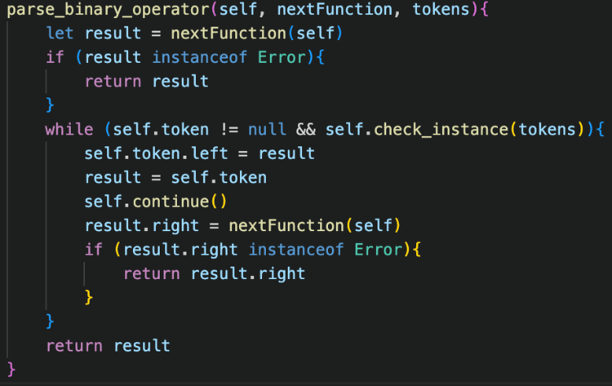Then, throughout the code, with examples shown on the left, the error calls can be inserted when required. For instance, replacing the old, printed message for not having closed a bracket, as well as a new addition at the end of factor(), which will be flagged when a token which was not a literal or a bracket was entered: such as two tokens in a row, which then throws an error referencing the token with the issue so that the program knows.

Additionally, the parse_binary_operator() method must not build these Error objects into the abstract syntax tree, so every time a different method is called, it must be checked if the result was an error.

If it was, that error is returned by the method, and is not build into the tree, and if it isn’t then it can continue as normal. This therefore ensure that any error will surface as the result in the parse() method regardless of where the error occurred in the parsing process to that point.

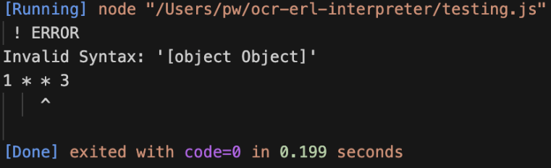When testing, the error message was flawed as it was trying to print the object, so I changed the message() to a different message that would not be as confusing.

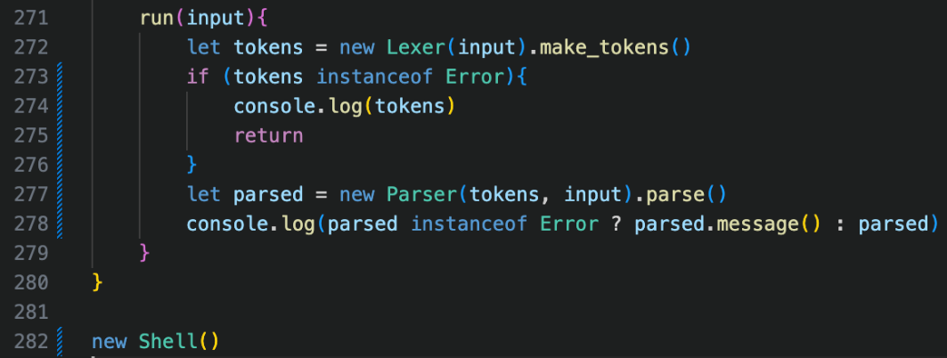Finally, I implemented the system back into our temporary Shell feature, so that our run() method would now correctly also parse the result from lexer whilst checking for any error. Although this is not long term, it will make checking for errors in the medium term significantly easier.

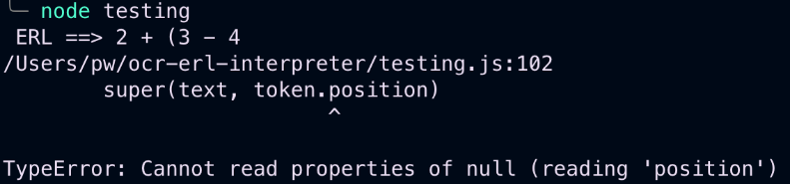For example, when trying to get an unclosed brackets error, it causes the program to crash, because a non-existent token is trying to be referenced for its position.

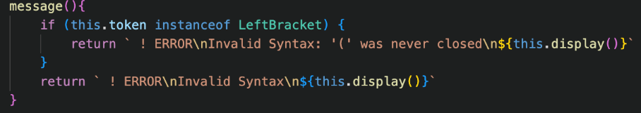The solution here is storing the initial bracket in a variable and returning that as the token with the error because it seems like the logical solution. I also updated the message() method to help explain better.

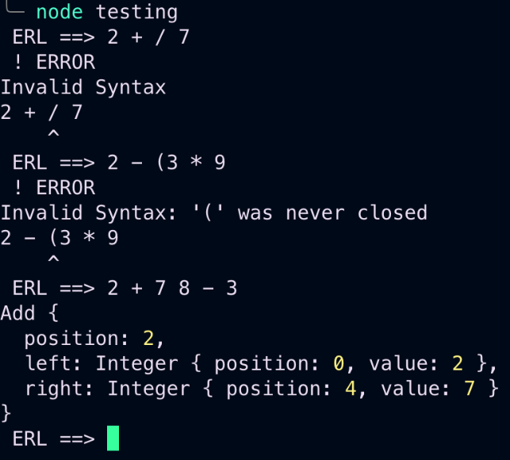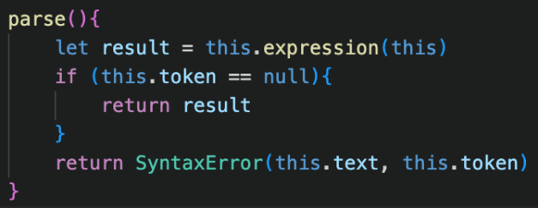Now you can see that two out of three of the main errors can be flagged, but having two literals in a row still causes the program to produce an incorrect result.

Adding this at the end of the parse() method, as explained in Design, will catch any of these errors with two literals occurring in a row. Initially, an error occurred as I did not use the new keyword, but afterwards it worked as intended and then flagged the error.

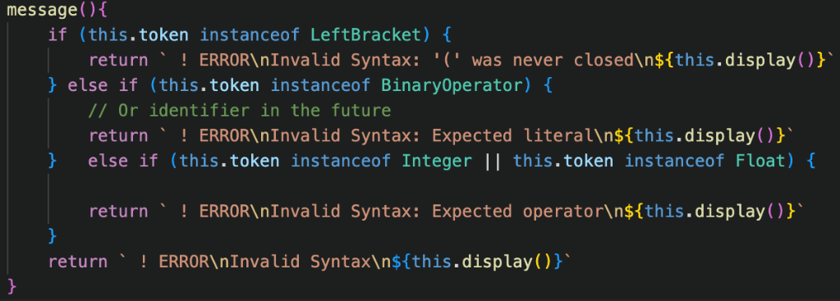The final addition was customising the message() method in Syntax Error to give a more detailed description on what the error is, based off the token that flagged the error. This overall gave us the result on the right, which I am happy with for this current stage.

bodmas execution

# Design

For this final addition, no extra main class is created for execution, but instead the Token classes are finally getting expanded to include some significant code.

The concept behind has already been explained prior, but in short, all Tokens which could end up being incorporated into the abstract syntax tree (excluding punctuation therefore) all have an evaluate() method.

This will return their “value”. This is simple for Integers and Booleans, which return their own value property when their evaluate() method is called. For binary operators, they will call the evaluate() method of their children and then operate on that instance. For example, the Plus tokens’ evaluate() method will return left.evaluate() + right.evaluate().

This stage is relatively simple to implement, but error handling also needs to be considered.

🡺 Math Errors

Some arithmetic operations are illegal. The two instances of this are attempting to divide by 0, as well as raising certain negative numbers to certain powers which create imaginary numbers. Therefore, in the evaluate() method of Divide and Exponent, we will check if this occurs, and if it does, we return the new Math Error. Then, we need error checking in every Binary Operators evaluate() method to ensure that if either of its children returned an error, it returns that error too, without crashing the program by trying to perform arithmetic on an object.

So, therefore to execute the abstract syntax tree, we just call the evaluate() method of the root node, and from there the program should execute, and we can output the result.

